Edward J. Schultz
1915 – October 7, 1943

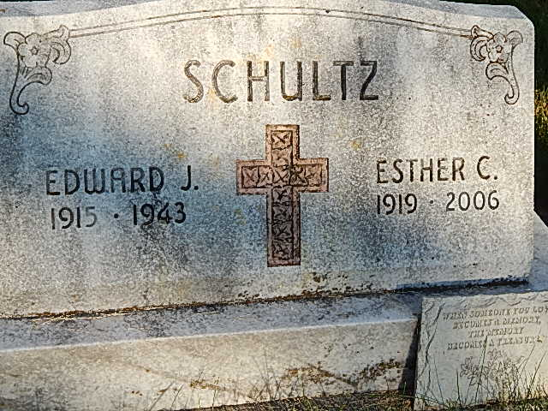
Photo by Alicia Kneuss
Friday, October 8, 1943

Telephone Company Lineman Is Killed
Edward J. Schultz Funeral on Monday

Funeral services will be held Monday morning at 9 o’clock at the St. Mary’s Catholic Church for Edward J. Schultz, 27, lineman for the Citizens Telephone Company here, who was electrocuted near Berne late Thursday. Rev. J. J. Seimetz will officiate and burial will be in the Decatur Catholic Cemetery.
The young man died instantly shortly before 3 pm Thursday when he accidentally came in conduct with a 6,600 volt electrical line while installing telephone service at a farm home, one mile south of Berne, recently purchased by O. N. Smith of that town.
County Coroner Robert J. Zwick, who investigated said death came instantly by electrocution. The story of the accident was given to Coroner Zwick by Chester Heare, 36, another employee of the company, who was working with the victim. Heare told Coroner Zwick that they were stringing the telephone line on poles of the Indiana Service Corporation, as is customary after securing permission and that they were working on the last pole – a pole which held the ISC transformer, designed to cut the power from 6,600 volts to the customary 110 house voltage. Heare said that Schultz climbed the pole and that he went to the barn nearby to secure some material. Heare said he heard a noise and turned to see Schultz hanging on the pole, smoking curling from his body. Rushing to the spot, he said he could see that Schultz had not survived and immediately drove into Berne to get Norbert Hoffman, an ISC worker, to turn off the current. Hoffman turned off the current and cut down Schultz’s body, then hanging on a safety belt after a wire burned away and the current released him.
Investigation disclosed that both of the victim’s hands were severely burned, as were his right leg and left arm. Heare called his father, Charles Heare, superintendent of the company in this city soon after the incident and Mr. Heare went to the site immediately. Last rites were administered by Rev. J. J. Seimetz at the scene. Mr. Heare said that this was the first fatality for the company in his 42 years as superintendent and only the second incident of its kind. A Berne man was injured about a decade ago. Regarding yesterday’s casualty, he said that the creosoted pole, in which the victim spurs were hooked, formed a perfect ground for the entire voltage.
Schultz had worked for the telephone company for the past four years, Mr. Hearn said. He had been sent to Berne yesterday to aid Chester Heare in installing the line, after the latter suffered a sprained ankle. The victim is survived by his parents, Julius and Isabelle Bernard Schultz, of South of Decatur; the widow, Esther Geimer Schultz; two children, Caroline and Edward; four sisters, Mrs. Mary Geimer and Mrs. Naomi Tricker of near here; Vera and Juliann at home; two brothers, Raymond and John of near Decatur. He was a graduate of Decatur Catholic High School and was a member of the St. Mary’s Catholic Church, of the Holy Name Society and of the Loyal Order of Moose. His father is a member of the county council. The body was to be removed to the residence, three miles east of Decatur, from the Gillig & Doan Funeral Home late this afternoon.

Adams County Historical Museum
1943B Scrapbook, images 059-060
Transcribed by Jim Cox

*****
(Handwritten date: Friday, October 8, 1943)

EDWARD SCHULTZ ELECTROCUTED AT O. N. SMITH FARM
Decatur Phone Lineman Meets Tragic Death South of Town Thurs.

Edward J. Schultz, 27, of near Decatur and a lineman for the Citizens Telephone company, was instantly killed by electrocution about 2:30 o'clock Thursday afternoon at the O. N. Smith farm a mile south of town, when a wire he was attempting to install as a ground wire came into contact with a 6,700-volt current at a transformer on a utility pole on which he was working.
Mr. Schultz and Chester Heare, local linemen, had gone to the farm to install a telephone where the tragedy occurred. The unfortunate young man is married and the father of two small children. He had been regarded as a capable workman, but at the moment of his death he was working with a piece of wire about eight or ten feet long and the lower end apparently (cut) dangled against the lower part of a transformer touching a hot spot on an insulator.
No one witnessed the accident. At the moment Mr. Heare and a small son of Victor Simon, had gone to the Simon barn nearby to see some of the remodeling that has been going on. Suddenly, Mr. Heare heard a loud cracking, hissing sound. Apprehensive of what may have happened, he ran out of the barn, in time to see the body of Mr. Schultz fall limp back into his climbing harness and a large puff of smoke rise into the air above him.
He hurried to summon help but by the time help arrived it was apparent that the body was far beyond resuscitation. It was almost an hour until it was lowered.
Norbert Hoffman, local Indiana Service Corporation lineman snipped the live wires leading to the transformer to make lowering of the body safe, and he went up to lower it with ropes.
Both hands of the dead man were terribly burned. The ends of the thumb and index finger on the right hand were practically burned off and a deep burn was made on the left hand. Where the wire and the hands contacted, the wire was almost melted. The forearms also showed burns and a hole was burned in one trouser leg where evidently the wire had touched his body.
Mr. Heare was overcome with grief and was brought to town by his father, Charles Heare, an executive of the company, whom he had summoned.
Mr. Schultz and Mr. Heare have been working here in town the past few days.
The elder Mr. Heare said that this was the first electrocution that he knows of in the history of his company, he having been with the firm for 43 years. Dale Eley was a near victim some years ago, leaving his hands crippled.
Mr. Schultz has been with the company about eight years altogether, having been also with the Central Soya company and returned to the lineman work about a year ago.
He was a son of Julius and Isabell (Bernard) Schultz, residing south of Decatur on road 27. (cut off)

Adams County (IN) Historical Society
1943b Scrapbook, Image 150
Transcribed by Karin King

