Minnie M. (Blauvelt) Schumacker
February 17, 1887 – August 14, 1969
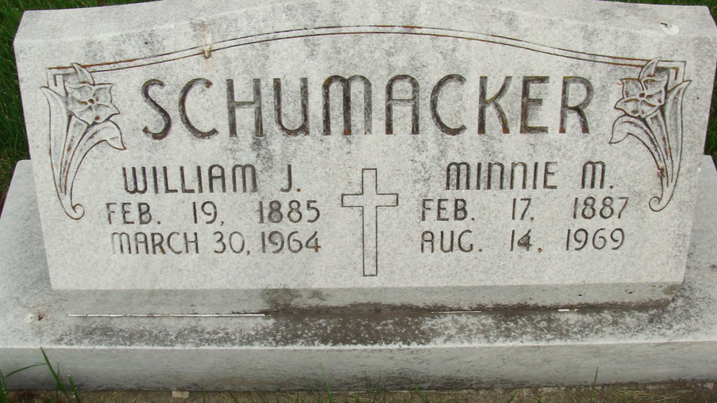
Photo by Alicia Kneuss

Minnie Schumacker dies at hospital

Mrs. Minnie M. Schumacker, 82, of 923 Mercer avenue, widow of William J. Schumacker died at 2:55 p.m. Thursday at the Adams county memorial hospital, following an extended illness.
She was born in Van Wert county, O., Feb. 17, 1887, a daughter of August and Mary K. Geiger-Blauvelt, and was married to William J. Schumacker May 24, 1918. Her husband preceded her in death March 30, 1964.
Mrs. Schumacker was a member of St. Mary’s Catholic church, the Rosary society, Catholic Ladies of Columbia, St. Vincent DePaul society, and the St. Anne Grandmothers club.
Surviving are two daughters, Mrs. Lawrence (Margaret) Beal, and Mrs. James (Catherine) Murphy, both of Decatur; three brothers, Carl, Orley and Lon Blauvelt, all of Fort Wayner; two sisters, Mrs. Bertha Manter of Fort Wayne, and Mrs. Josephine Den of Toledo, O.; six grandchildren and seven great-grandchildren. Three brothers and three sisters are deceased.
Funeral services will be conducted at 10 a.m. Monday at St. Mary’s Catholic church, with the Rt. Rev. Msgr. Simeon Schmitt officiating. Burial will be in the Catholic cemetery. Friends may call at the Gillig Doan & Sefton funeral home after 7 p.m. Saturday until time of the services. The rosary will be recited at 8 p.m. (8-14-69)

Decatur (IN) Public Library Obit Book E, image 31, p. 29

Transcribed by Janice Vasilovski

