Anne K. (Colchin) Smith
1909 – January 28, 1961
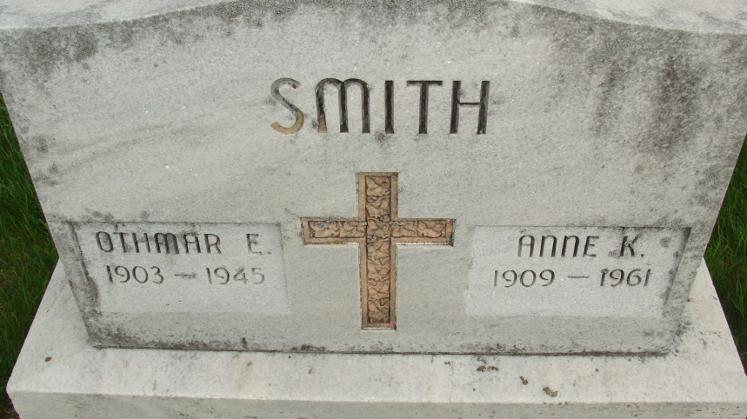
Photo by Alicia Kneuss

Dated January 28, 1961

Mrs. Anne Smith Killed In Accident

Mrs. Anne K. Smith, 51, a resident of Decatur most of her life, and prominently known in this city, was killed almost instantly in a two-fatality traffic accident at 9:45 p.m. Saturday on U. S. highway 27, two miles south of Fort Wayne near the Hessen Cassel church.
Clyde W. Thomson, 47, of Harrisburg, Pa., driver of the car in which Mrs. Smith was riding, died at 3:30 a.m. Sunday at the Lutheran hospital of a crushed chest and other injuries.
The traffic victims, who planned to be married in February, were enroute to visit friends and relatives of Mrs. Smith in Decatur when the tragedy occurred.
Others Serious
Three occupants of the second auto are reported still in serious condition at the Lutheran hospital. They are the Rev. Kenneth T. Watkins, 39, of Columbia City, the driver; his 38-year-old wife, Betty, and their son, Ken D., 7. A daughter, Jean Ann, 11, was released after treatment. The Hawkins family was returning home after attending funeral services at the Bethel Brethren church, east of Berne, for Mrs. Donald Haines, a relative of the family. Rev. Hawkins is a brother of Al Hawkins, of Decatur route 5, Decatur General Electric Co. employee.
State troopers Sam Platt and Darrell Bauer, and Richard Shull, Allen county deputy sheriff, who investigated, said evidence indicated the Thompson vehicle was apparently turning around on U. S. 27 and pulled into the path of the Hawkins car.
Herman Mason, 54, of Fort Wayne, and his wife, Eva, 54, were reported in serious condition at Parkview memorial hospital, suffering from injuries sustained when Mason’s car crashed into two parked cars at the scene of the mishap.
With Central Soya
Mrs. Smith who was recently given a 25-year service award from the Central Soya Co., for many years was in the traffic department of the company’s offices in this city, and has been secretary to Central Soya’s rail traffic management in the Fort Wayne offices for several years.
Thompson was a division sales manager of Central Soya’s McMillen Feed division in Harrisburg, Pa. He had previously held several sales positions with the Central Soya and from 1958 to 1959 was in the Fort Wayne office.
Mrs. Smith, a native of Brooklyn, N. Y., was the adopted daughter of the late Mr. and Mrs. William Colchin, and lived in Decatur until moving to Fort Wayne two years ago.
Funeral Wednesday
Mrs. Smith was president of the Fort Wayne Women’s Traffic club, and was a member of the Queen of Angels Catholic church in that city. Her husband, Othmar Smith, preceded her in death in 1945.
Surviving are two daughters, Miss Kathleen Smith of Sandusky, O., and Mrs. George Liscopoulos of Columbus, O., and a granddaughter.
Funeral services will be held at 9:30 a.m. Wednesday at the Chalfant-Perry funeral home and at 10 a.m. at the Queen of angels church, the Rev. Denis H. Blank officiating. Burial will be in the Fort Wayne Catholic cemetery. Friends may call at the funeral home after 4 p.m. today. Rosary services will be at 7:30 p.m. Tuesday at the funeral home.
Thompson, a native of Illinois, had been a Central Soya employee about 16 years. He was a member of the Fort Wayne Elks lodge, the Masonic lodge at Gibson City, Ill., and the Scottish Rite at Bloomington, Ill. Survivors include his mother, Mrs. Grace Thompson of Champaign, Ill. Services will be held Tuesday at Decatur, Ill.

*****
No date
Anne Smith Burial in Local Cemetery
Funeral services for Mrs. K. Smith, killed in a traffic accident Saturday night near Fort Wayne, will be held at 9:30 a.m. Wednesday at the Chalfant-Perry funeral home and at 10 a.m. at the Queen of Angels Catholic church. The Rev. Denis H. Blank will officiate. The body will be brought to Decatur for burial in the Catholic cemetery. Friends may call at the funeral home in Fort Wayne until time of services.
Decatur (IN) Public Library Obit Book A, p. 59
Transcribed by Janice Vasilovski

