Henry Stetler
1835 – May 26, 1915

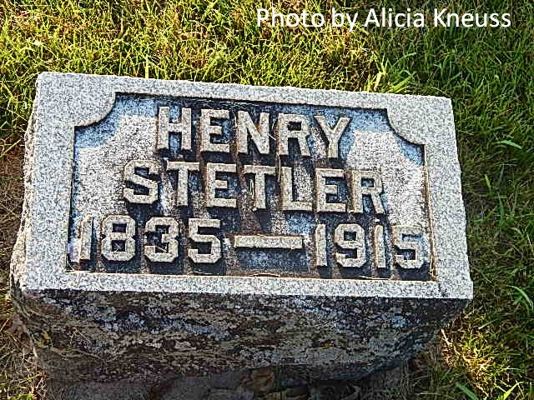

WAS WELL KNOWN
Henry Stettler, Former Resident of Adams County, Died at Lima, Ohio
AT 1:30 WEDNESDAY
Death Due to Advanced Age -- Body Will be Brought Here For Burial
Word was received yesterday afternoon by Mrs. George Chronister of this city of the death of her father, Henry Stettler, which occurred Wednesday afternoon at 1:30 o'clock at the home of another daughter, Mrs. Peter Stein, at Lima, Ohio, and at which place for the past two or three years Mr. Stettler had been making his home. Death is thought to have resulted from advanced age, the deceased having been in his seventy-ninth year, and since the death of his wife last January, Mr. Stettler had been declining in health. The deceased was well known to Adams county residents, he having practically spent his life in this county until several years ago, when he moved to Lima and entered the mercantile business. Two daughters and one son survive the father, they being Mrs. Peter Stein of Lima, Ohio; Mrs. George Chronister of this city and Benton Stettler. The body will be brought to the home of Mrs. Chronister tomorrow noon and services will be held Saturday morning at the St. Mary's Catholic church.

Decatur Daily Democrat, Adams County, Indiana; Thursday, May 27, 1915

Contributed by Karin King

