Everett Studabaker
April 7, 1904 – November 10, 1971

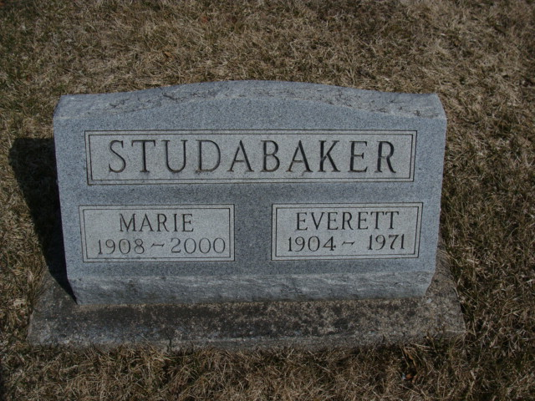
Photo by Alicia Kneuss

Everett Studebaker dies of heart attack

Everett Studebaker, 67, of 13026 Bluffton road, Fort Wayne, died at 12:30 p.m. Tuesday at his home following a heart attack. He had been in poor health four years.
He was a native of Bluffton and resided there until moving to Allen county in 1954. He retired four years ago from the Allen county highway department.
Mr. Studebaker was a member of the Moose lodge at Bluffton.
Surviving are his wife, the former Miss Marie Zeser of Decatur; a sister, Mrs. Josephine Reed of Logansport; a half-brother, Robert Studebaker of Virgil, Kan., and a half-sister, Mrs. Ella Bushing in California.
Funeral services will be held at 1:30 p.m. Friday at the Thoma funeral home in Bluffton, with Rev. Walter Graeflin officiating. Burial will be in the Catholic cemetery in Decatur. Friends may call at the funeral home after 7 p.m. today until time of the services. (Nov. 10, 1971)

Adams County Library, Decatur, IN
Obit Book F, image 74
Transcribed by Janice Vasilovski

