Eugenio S. Torres, Jr.
May 16, 1937 – March 17, 2018

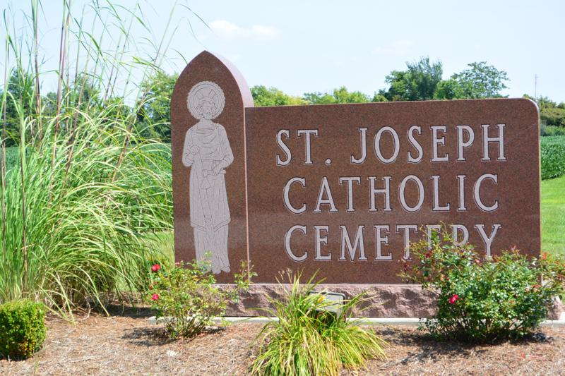
Eugenio S. "Geno" Torres Jr., 80, of Ft. Wayne, IN, passed away on Saturday, March 17, 2018, at Lutheran Life Villages. He was born on May 16, 1937, in Rio Piedras, Puerto Rico, the son of the late Eugenio and Angelina (Santiago) Torres Sr.
He was a parishioner of The Cathedral of the Immaculate Conception. He retired in 2001 from Dana Corp. in Ft. Wayne after 36 years of service.
Geno is survived by 2 sons, Peter Torres and Marcos (Deborah) Torres both of Ft. Wayne; 4 sisters, Elisa (Cristobal) Jordan, Juanita (Alberto) Palacios, Edelmira (Onnie) Drewery and Maria Bilger all of Ft. Wayne; 4 grandchildren, Morgen, Olivia, Sofia, and Bradley.
He was preceded in death by 2 brothers, Juan Torres and Luis Torres and 4 sisters, Ana Gonzalez, Carmen Torres, Antonia Leal, and Luz Maria Ortiz.
Visitation will be from 4:00 – 8:00 p.m. on Thursday, March 22, 2018, at D.O. McComb & Sons Foster Park, 6301 Fairfield Ave., Ft. Wayne, with a reciting of the Holy Rosary at 7:30 p.m.
A Mass of Christian Burial will be held at 10:00 a.m. on Friday, March 23, 2018 at The Cathedral of the Immaculate Conception 1122 S. Clinton St., Ft. Wayne, with visitation 1 hour prior to the service from 9:00 – 10:00 a.m. Presiding will be Father Peter DeeDe and burial will take place in the Catholic Cemetery.
The arrangements handled by Haggard-Sefton-Hirschy & Zelt Funeral Home, Decatur, IN.

Haggard-Sefton & Hirschy Funeral Home online obit (accessed 3/19/2018)

