Fred M. Ulman
July 27, 1904 – April 21, 1968
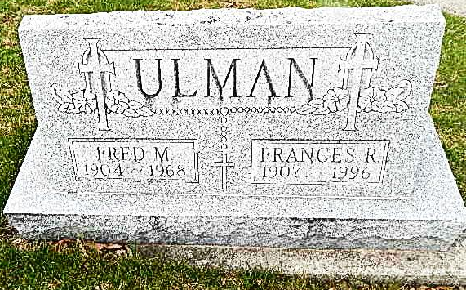
Photo by Alicia Kneuss

Fred Ulman dies at home here Sunday

Fred Ulman, 63, retired farmer, died at 12:40 p.m. Sunday at his home, 931 North Fifth street. He had been in failing health for some time and critically ill for the past two weeks.
He was born in Root township July 27, 1904, a son of Victor and Anna Hackman-Ulman, and was married to Frances Omler Nov. 23, 1926. He farmed in Union township for 34 years before retiring in 1965.
Mr. Ulman was a member of St. Mary’s Catholic church and the Holy Name society.
Surviving are his wife; one son Thomas Ulman of Decatur route 3; one daughter, Mrs. John (Mary Ann) Braun of Decatur route 4, his father, Victor Ulman of Decatur; three brothers, Herman and Robert Ulman, both of Decatur route 5, and Clarence Ulman of Libertyville, Ill.; two sisters, Mrs. John (Frances) Schurger of Decatur route 4, and Mrs. Oscar (Helen) Scheiner of Decatur route 3; and nine grandchildren. One son, one daughter and one granddaughter are deceased.
A solemn requiem mass will be celebrated at 10 a.m. Tuesday at St. Mary’s Catholic church with the Rt. Rev. Msgr. Simeon Schmitt iin charge. Burial will be in the Catholic cemetery. Friends may call after noon today at the Gillig-Doan & Sefton funeral home until time of the services. The rosary will be recited at 8:30 o’clock this evening.

(April 22, 1968)

Decatur Library (IN) Obit Book E, page 7
Transcribed by Janice Vasilovski

