Joseph L. Wolpert
December 17, 1878 – January 2, 1933
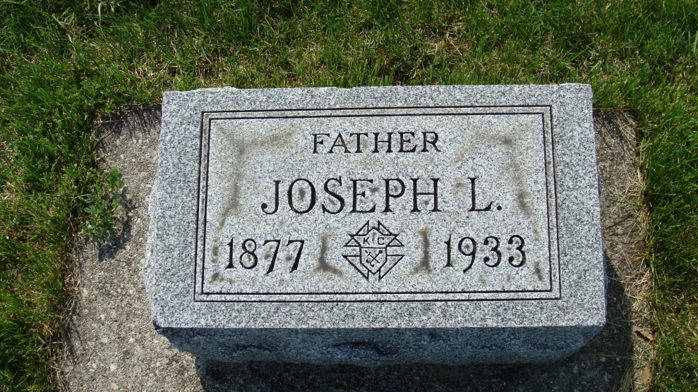
Photos by Alicia Kneuss

Joseph Wolpert, of Decatur, died of pneumonia after a short illness. He was aged 54 years and long an employe of the Cloverleaf Creamery.
Van Wert Daily Bulletin, Van Wert County, Ohio; January 5, 1933

Contributed by Karin King

