Curtis D. Linker
April 7, 1952 – January 3, 2018
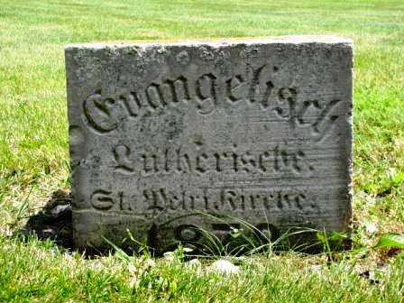
Photo by Barbara Baker Anderson
Curtis D. Linker, 65, of Monroeville, Indiana passed away Wednesday, January 3, 2018 at Parkview Hospital - Randallia in Fort Wayne following a brief illness and his death was unexpected.
He was born on Monday, April 7, 1952 in Fort Wayne, Indiana the son of the late Donald Linker and the late Anne Marie (Nern) Linker. He married Linda Williams June 17, 2000 in St. Peter Lutheran Church, Fuelling.
Curt graduated from Heritage High School. Following graduation, he worked at International Harvester and Zollner Pistons along with Fleetwood Motor Homes in Decatur. He was also involved as an owner and operator of a lawn care service, Linker Lawncare, for 26 years.
He was a member of St. Peter Lutheran Church, Fuelling where he was a former deacon and church grounds custodian. He was also an avid Notre Dame and Boston Red Sox fan and enjoyed coon-hunting in his younger years.
Survivors include his wife, Linda Linker of Monroeville; sister, Marilyn (Larry) Lyman of Valparaiso; brother, Bruce (Mary) Linker of South Haven, MI; nephew, Jeff (Holly) Trier; & two nieces, Jodie Genth & Meredith (Josh) Johns.
He was preceded in death by a sister, Cindy Adams.
A memorial service will be held at 4:00 p.m. Saturday, January 6, 2018 at St. Peter Lutheran Church, Fuelling with Rev. Martin Moehring officiating. Friends will be received for one hour prior to the memorial service Saturday at the church.
Preferred memorials are to St. Peter Lutheran Church, Fuelling.

Zwick & Jahn Funeral Home online obit (accessed 1/6/2017)

