Willis Edward Brock
October 2, 1931 – March 10, 2007
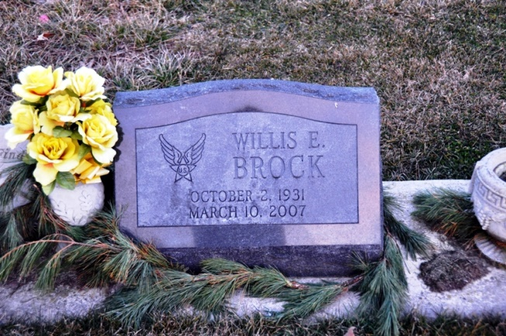
Photo by Deb Curry

Willis E. Brock, 75 of Decatur passed away Saturday, March 10, 2007 at Lutheran Hospital in Fort Wayne. Willis was the son of Edward L. & Margaret H.M. Brock. He was born in Fountain County, IN. He married Carolyn J. Waltmire Everett on September 18, 2004, she survives. Other survivors are 3 step sons Roger L. Everett of Bluffton, Ronald A. & Robert E. Everett both of Decatur; 1 brother Keith Cooper of Crawfordsville; 1 sister Jodi Riley of Indianapolis; 6 step grandchildren and 5 step great grandchildren. Preceded Willis in death are 2 brothers, 1 step daughter and 1 step son. He retired from the United States Air Force and was a member of the American Legion Post 43. Visiting hours are from 4-8 pm Tuesday, March 13, 2007 at Haggard & Sefton Funeral Home. Funeral services will be held on Wednesday, March 14, 2007 at 2:00 pm also at the funeral home. Rev. Keith Rupp will be officiating and burial is at Mt. Tabor Cemetery. Memorials are to American Legion Color Guard.

Haggard-Sefton & Hirschy Funeral Home online obit (accessed 2/24/2013)
*****

WILLIS EDWARD BROCK, 75

The stepfather of Roger L. Everett of Bluffton, Willis Edward Brock, 75, of Decatur passed away Saturday, March 10, 2007, at Lutheran Hospital, Fort Wayne.
Mr. Brock was retired from the U.S. Air Force. He was a member of American Legion Post #43.
Born on Oct. 2, 1931, in Fountain County, Ind., he was a son of Edward L & Margaret H. M. Brock. His marriage on Sept. 18, 2004, was to Carolyn J. Waltmire Everett Brock, who survives.
Other survivors, in addition to the stepson in Bluffton, include stepsons Ronald A. Everett and Robert E. Everett, both of Decatur; a brother, Keith Cooper of Crawfordsville; a sister, Jodi Riley of Indianapolis; six stepgrandchildren; and five stepgreat-grandchildren.
He was preceded in death by two brothers, a stepdaughter and a stepson.
Calling is from 4 to 8 p.m. Tuesday at Haggard & Sefton Funeral Home, Decatur.
Services are at 2 p.m. Wednesday at the funeral home with Rev. Keith Rupp officiating.
Burial will be in Mt. Tabor Cemetery. Preferred memorials are to the American Legion Color Guard.

Bluffton News-Banner, Wells County, IN; Monday, March 12, 2007, p. 3, c. 1

