Clara Matilda (Beaver) Bischoff
October 22, 1890 – July 23, 1957

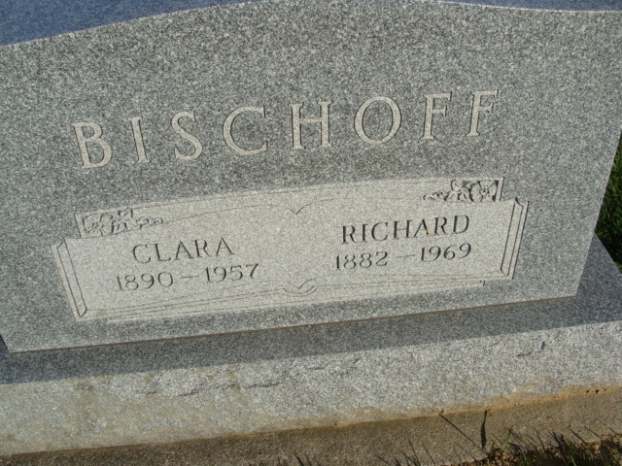
Photo by Alicia Kneuss

Mrs. Clara Bischoff Dies This Morning
Heart Attack Fatal Early This Morning

Mrs. Clara Bischoff, 66, a resident of Union township for 48 years, died suddenly at 8 o’clock this norning at her home, nine miles northeast of Decatur, following a heart attack early this morning.
She was born in Huntington Oct. 22, 1890, a daughter of Mr. and Mrs. Henry Beaver, and was married to Richard C. Bischoff Nov. 23, 1909.
Mrs. Bischoff was a member of the Immanuel Lutheran church.
Surviving in addition to her husband are four daughters, Mrs. George Theilacker of Pasadena, Calif., Mrs. Hugh Landis of Kirkland township, Mrs. Michael Hebor of Pasadena, Calif., and Mrs. Paul Buesching of Fort Wayne; two sons, Arthur and Carl Bischoff, both of Union township; 13 grandchildren; one brother, Burton Beaver of Denver, Colo., and one sister, Mrs. Rebecca Fulton of Huntington.
Funeral services will be conducted at 1:30 p.m. Friday at the Zwick funeral home and at 2 p.m. at the Immanuel Lutheran church, the Rev. W. C. Vetter officiating. Burial will be in the church cemetery. Friends may call at the funeral home after 7 p.m. Wednesday until time of the services. The casket will remain closed at the church.

Zwick Funeral Home, Adams County, Indiana
July 24, 1957

**
Indiana, U.S., Death Certificates, 1899-2017
Name: Mrs. Clara Bischoff
[Mrs. Clara Beaver]
Gender: Female
Race: White
Age: 66
Marital status: Married
Birth Date: 22 Oct 1890
Birth Place: Indiana
Death Date: 23 Jul 1957
Death Place: Decatur, Adams, Indiana, USA
Death Registration Date: 1957
Father: Henry Beaver
Mother: Unknown
Informant: Richard C. Bischoff; husband; Decatur, Indiana
Burial: July 26, 1957; Immanuel Lutheran Cemetery; Decatur, Indiana

