Lawrence E. Lichtenberger
June 12, 1929 – August 22, 1949

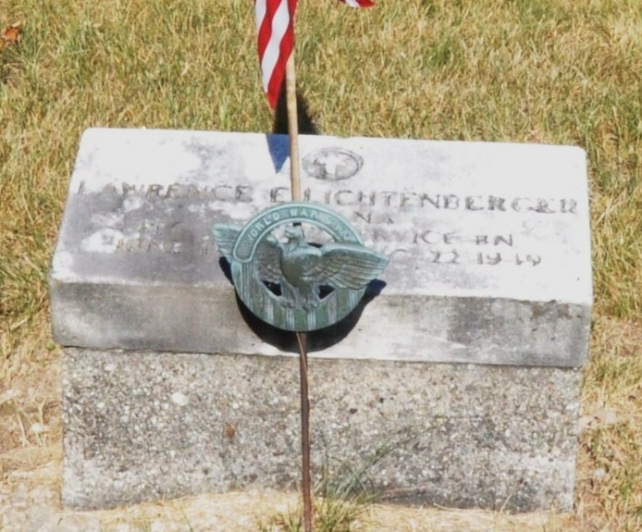
Photo by Deb Curry
Funeral services will be conducted Sunday at 2 P. M. at the Calvary
Evangelical United Brethren Church east of Decatur, Ind., for Pfc. Lawrence E Lichtenberger, 19, brother of Mrs. Herbert K. Walker of Congress Street. Pfc. Lichtenberger died of a skull fracture – the result of a fall which (sic) fishing near Chienesee, Germany, August 22, 1949.
According to word received here from the Department of the Army, Pfc. Lichtenberger, who had been stationed in Germany with occupation troops, since last December, fell and struck his head while fishing. He was attached to a military police outfit in Germany.
The body arrived in Decatur today and will be taken to the home of the parents, Mr. and Mrs. William H. Lichtenberger of near Decatur, Saturday. The Rev. Albert Straley will conduct services Sunday.
Besides his parents and Mrs. Walker, the deceased is survived by three other sisters: Mrs. Raymond Derble of Ossian, Ind.; Mrs. Dale Beer of Monroe, Ind., and Kathryn at home and three brothers: Lloyd, Carl and Raymond, all at home.
Van Wert Time Bulletin, Van Wert County, Ohio
September 23, 1949
**

U.S., Headstone Applications for Military Veterans, 1861-1985
Name Lawrence Lichtenberger
Birth Date 12 Jun 1929
Service Number Ra 19 323 421
Unit 508th Military Police Ser Bn
Company 508th M.p. Sv. Bn. Co.c
Enlistment Date 12 Oct 1948
Death Date 22 Aug 1949
Cemetery Salem Cemetery
Cemetery Location Adams, Indiana, USA

