John S. Schwartz
1960 – May 13, 1963

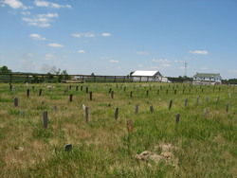
Photo by Jenna Langston

Three-Year-Old Boy Dies At Hospital
Johnnie Schwartz, 3, son of Mr. and Mrs. Christian Y. Schwartz of Geneva Route 2, died Monday afternoon at the Adams County Memorial Hospital where he was admitted earlier in the day.
Death was attributed to gastronomies. The child was treated at the office of a Berne physician Saturday for burns to the lower part of his body, caused when he fell into a pail of scalding water. Monday, the child became much worse and was brought to the hospital. The parents said the child had been ill with influenza the past winter and recently suffered a recurrence.
Surviving are the parents, two brothers and six sisters, and the grandparents, Mr. and Mrs. Sam C. Schwartz and Mr. and Mrs. Sam Hilty.
The funeral will be held at 2 p.m. Wednesday at the Samuel C. Schwartz residence. Friends may call at the home of the parents until time of the services.

Decatur Daily Democrat, Adams County, IN; May 14, 1963

