Mary E. (Showalter) Burley
December 8, 1855 – September 19, 1919

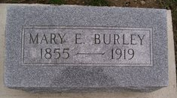
Photo by Scott Shoup
MRS. J. T. BURLEY OF WABASH TOWNSHIP DIED FRIDAY
After an illness of only five days, Mrs. Mary (Showalter) Burley died Friday afternoon at 4 o'clock at the family home in East Wabash Township. The deceased had been ill only since last Monday, when she had been exposed to a cold, which later developed into pneumonia and which resulted in her death. Mrs. Burley had been born in Ohio on Dec. 8, 1855, and was at the time of her death 64 years, 8 months, and 11 days old.
When still quite young, she was married to J. T. Burley, who survives her. Besides her husband, she is survived by six children, three sons and three daughters, and a large number of other relatives and friends.
The funeral services of Mrs. Burley were held yesterday afternoon at 2 o'clock at the home, after which the burial took place at the Bunker Hill Cemetery.

Berne Witness, Adams County, IN; September 22, 1919

Contributed by Karin King

