Barbara Ellen (Baker) Campbell
April 22, 1857 – May 6, 1950

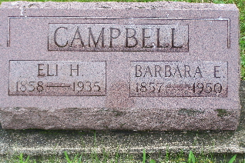
Photo by Scott Shoup

AGED GENEVA WOMAN DIES SATURDAY
Rites Tuesday for Mrs. Barbara Ellen Campbell, 92

Mrs. Barbara Ellen Campbell, 92, widow of Eli Campbell, died Saturday afternoon at the home of a daughter, Mrs. Elizabeth Callihan, in Geneva. She spent her entire life in Geneva and community, being born near Geneva August 22, 1857. Her husband died 15 years ago.
Surviving are the daughter, Mrs. Callihan; another daughter, Mrs. Louis Baumgartner, Geneva; a son, Clyde, of Geneva, and seven grandchildren.
The body was removed to the Hardy & Hardy Funeral Home, where services will be conducted at 2 p.m. Tuesday, the rev. Clayton Steele officiating. Burial will be in the Bunker Hill Cemetery.
Berne Witness, Adams County, IN; May 8, 1950

