John Taylor
June 28, 1844 – June 30, 1911

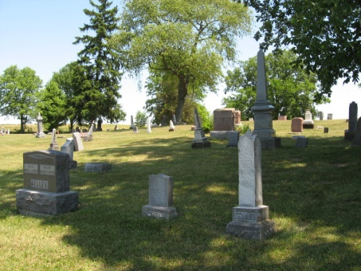
Photo by Tombstoner & Family
Mrs. Drake of Decatur, visited at the death bed of her brother, John Taylor, east of Berne last week. Mr. Taylor died Friday evening and his funeral was held Sunday.
Berne Witness, Adams County, Indiana; Tuesday, July 4, 1911
*****
COURT PROCEEDINGS
In his last will and testament probated today, John E. Taylor, whose death occurred June 30th, gives all his personal property, consisting of household goods, cattle, hogs, horses, poultry, and farm implements, all money, notes, mortgages, to his wife, Mary Taylor. He also leaves to his wife all his real estate, rents and profits as long as she lives. He asks that he be furnished with a fifty-dollar coffin, and that a sixty-dollar monument be erected at his grave. F. S. Armantrout and Robert E. Hickerson were witnesses to the will, which was executed March 31, 1911.
Berne Witness, Adams County, Indiana; Friday, July 7, 1911
Both contributed by Karin King
*****

Indiana, Death Certificates, 1899-2011
Name: John Taylor
Gender: Male; Race: White; Age: 67; Marital Status: Married
Birth Date: 28 Jun 1844, age 67 years old; Birth Place: Ohio
Death Date: 30 Jun 1911; Death Place: Wabash, Adams, Indiana, USA
Father: Wm Taylor; Mother: Susan Minchart; Spouse: Mary Taylor
Informant: Mrs. Wm. Drake of Decatur
Burial: July 2, 1911; Bunker Hill

