Calvin R. Adams
March 20, 1924 – April 27, 1972
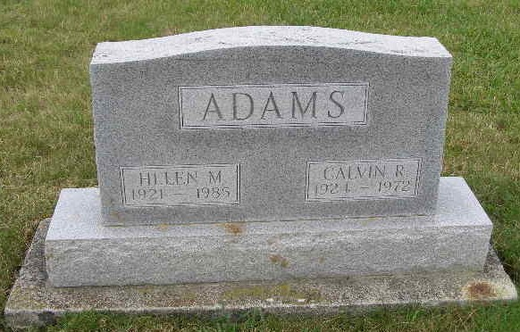
Photo by: Alicia Kneuss

Calvin R. Adams Dies Suddenly While at Work
Services Here Saturday for Local Man, 48

Calvin R. Adams, 48, 266 South Jefferson Street, died suddenly at 1:30 pm Thursday at the Dunbar Furniture Company, where he was employed for a number of years. Death was attributed to a heart attack.
Mr. Adams was employed in the Mill Room of the Dunbar Plant and served as an expediter. He had been ill with the flu recently and had a history of heart disease.
A native of Bryant, he was born March 20, 1924, a son of George and Ada Heineman Adams. He was married to Helen M. Ellenberger June 30, 1949, at Vincennes, Indiana.
Surviving are the wife; a sister, Dr. Mildred Adams, teacher of Nursing Education at Indiana University School of Nursing, Indianapolis and two brothers, John J. Adams, Fort Wayne and George W. Adams, Hicksville, New York. Several brothers and sisters are deceased.
Mr. Adams was a member of the Portland Chapter of the American Legion and was a veteran of World War II, serving in Europe. He was very interested in sports and in the local Little League program, serving as a Little League manager here for some time.
Services will be held at 2 pm Saturday, Rev. Wilson Bixler of the Cross United Church of Christ officiating. Burial will be in the MRE Cemetery.

Date of Death: April 27, 1972; Date of Burial: April 29, 1972; Burial: MRE

Berne (IN) Library Heritage Room MRE Obit Book 1966-1972
*****
Calvin R. Adams dies unexpectedly

Calvin R. Adams, 48, of 266 South Jefferson, Berne, died suddenly of a heart attack at 1:30 p.m. Thursday while at work at Dunbar Furniture Corp plant in Berne.
He was born at Bryant march 20, 1924, a son of George and Ada Heineman-Adams, and had lived in Adams county for 22 years. He was married to Helen M. Ellenberger in Vincennes June 30, 1949.
Mr. Adams, a veteran of World War II, was a member of the American Legion post at Portland.
Surviving are his wife; one sister, Dr. Mildred Adams, nursing education teacher at Indiana University school of nursing at Indianapolis, and two brothers, John J. Adams of Fort Wayne, and George W. Adams of Hicksville, N.Y.
Funeral rites will be held at 2 p.m. Saturday at the Yager funeral home in Berne, with Rev. Wilson Bixler officiating. Burial will be in MRE cemetery. Friends may call at the funeral home after 2 p.m. today.
Decatur Daily Democrat, Adams County, Indiana
Friday, April 28, 1972

