Charles Franklin Adams
June 1, 1879 – October 26, 1970
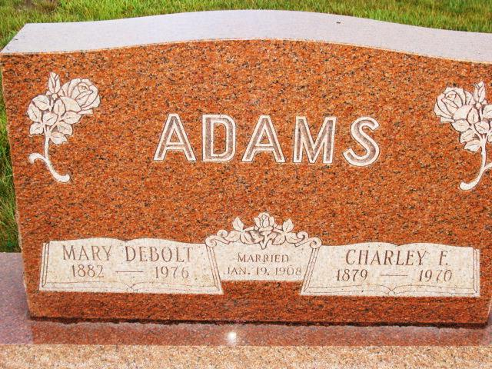
Photo by Alicia Kneuss

Date of Death: October 26, 1970; Date of Burial: October 29, 1970
Burial: Lot 11, Section 2, 4th Addition

Charley Adams Taken by Death Late Monday
Shock from Broken Hip Fatal; Rites Here Thursday

Charles Franklin Adams, 91, R.R. 2, Berne, a retired farmer, died at 7:50 pm Monday at the Adams County Memorial Hospital.
Mr. Adams fell and broke a hip last Thursday and his death is attributed to shock from the injury. He was taken to the hospital Monday and died several hours later.
He suffered a stroke ten years ago and had been confined to his home most of the time since. He was bedfast since January of this year.
A native of Jay County, Mr. Adams resided in Jefferson Township for the last 88 years. He was born June 1, 1879, a son of Albert F. and Barbara Ellen Rian Adams. He was married to Mary E. DeBolt January 19, 1908 in Jefferson Township. They spent 62 years of life together.
Surviving are three sons, Chester L. Adams, Glenn W. Adams and Ora S. Adams, all of R.R. 2, Berne; nine grandchildren and two great-grandchildren.
Mr. Adams attended the Mt. Carmel Church and was baptized by the pastor of the church.
The body is at the Yager Funeral Home where friends may call and where services will be held at 2 pm Thursday. Rev. Lyle Schmidt will officiate and burial will be in the MRE Cemetery.

Berne (IN) Library Heritage Room
MRE Obits 1966 – 1972
Transcribed by Jim Cox

