Dorcie (Broadstock) Affolder
November 29, 1891 – July 24, 1971
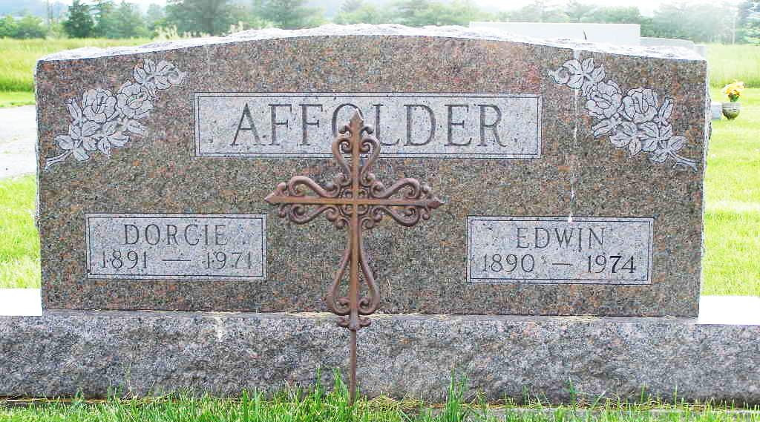
Photo by Shaunda Bedwell

Dorcie Affolder

Date of Death: July 24, 1971
Date of Burial: July 26, 1971
Burial: S ½ Lot 6, Section 2, 5th Addition

Rites Today for Wife of Edwin Affolder
Mrs. Dorcie Affolder, 79, Dies Suddenly Saturday

Services were held at 2 pm today at the Yager Funeral Home for Mrs. Dorcie Affolder, 79, wife of Edwin Affolder of R.R. 1, Berne, who died suddenly at her home at 5:15 pm Saturday.
Rev. Wilson Bixler, assistant pastor of the Cross United Church of Christ officiating at the rites and burial was in the MRE Cemetery.
Mrs. Affolder had been in failing health for five years, but death was unexpected. She lived with her husband on a farm a mile west and 1 ½ miles south of Berne where they have lived the last 54 years.
She was a native of Mercer County, Ohio but spent most of her life in this community. She was born November 29, 1891, a daughter of Tom and Ardella Fink Broadstock. She was married to Edwin Affolder December 14, 1912, in Berne.
Surviving are the husband; three sons, Edwin (Jack) Affolder, R.R. 2, Berne; Howard D. Affolder, a Berne City Policeman and Ray Affolder, R. R. 2, Berne. (cut off - bad scan)
Berne (IN) Library Heritage Room
MRE Obits 1969 – 1972
Transcribed by Jim Cox

