Noel L. Agler
September 4, 1927 – August 28, 2017

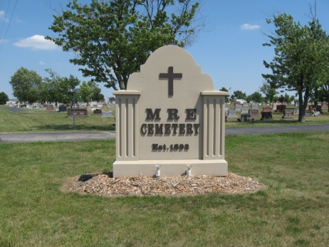
Photo by Tombstoner & Family

Noel L. Agler, 89, of Cape Coral, Florida, passed away on Monday, August 28, 2017. He was born on September 4, 1927 near Berne to Glen and Elva (Scoles) Agler. He was married on September 26, 1948 to Norma Baker.
He grew up on his family’s farm west of Berne. Immediately after graduation from Geneva High School in the spring of 1945, he enlisted in the United States Navy and served on a ship in the Pacific for the duration of World War II. After his honorable discharge from the Navy, he married the love of his life. They raised their family in Berne and moved to Florida upon retirement in 1992.
He worked for the Berne Furniture Company for 45 years. He was a master at upholstering and wood finishing. After building furniture for most of his career, he then became a manager. He also owned and operated a carpet cleaning business. As a faithful Christian, he had a desire to help others. He served on committees at his church, and trained and served as an EMT in Adams County during the early development of the county’s emergency services. He had a keen interest in politics and served as a Democratic precinct chairman.
He was known for being sweet and sentimental, as well as having an ornery sense of humor, sparkling blue eyes, strong work ethic, fondness for dogs, and intense love for his family. He was ahead of his time when it came to traditional family roles, as he supported his wife’s desire to have a career as a nurse and shared equally with her in homemaking duties, cooking, and the care of the children. He was a devoted father who enthusiastically took his family on scenic and fun vacations from Canada to New England to Florida. In his spare time, he enjoyed collecting coins and pocket knives, watching television shows and Indiana University basketball, reading novels, listening to Gaithers’ gospel music, and building and finishing grandfather clocks. In his later years, he took up the hobby of painting pictures and was a loving grandfather who greatly enjoyed playing cards with his grandchildren.
He is survived by two daughters, Paula (Thomas) Eckerty; and Janelle McKinley, both of Cape Coral, Florida; two sons, Thomas (Ann) Agler of Lawrenceville, Illinois; and Timothy (Deborah) Agler of Fort Wayne; sister, Betty Hawkins; nine grandchildren, Kristen Eckerty; Erin Stoffel; Leslie Caughran; Matthew Agler; Sean Agler; Drew Agler; Brooke Clark; Holly Koehler; and Kara Powell; seventeen great-grandchildren; and many nieces and nephews.
He was preceded in death by parents; his wife in 2012; two brothers, Donald Agler; and Albert Agler; and three sisters, Thelma Liechty; Norma Sprunger; and Nolda Hendricks.
A memorial ceremony with military honors will be held in Cape Coral, Florida with burial at a later date in MRE Cemetery in Berne.
Memorials may be made to Healthpark Hospice of Lee County, Florida or the Alzheimer's Association sent in care of the family will be forwarded to the charity.
Contributed by Alicia Kneuss – no source listed

