Emma Lou (Riesen) Ahr
February 19, 1925 – September 27, 2017
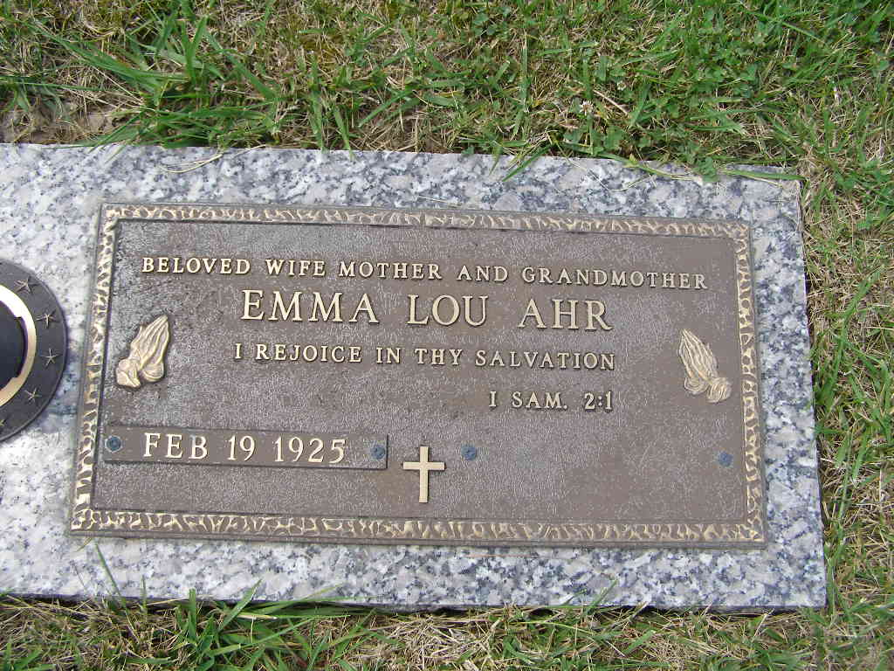
Photo by Shaunda Bedwell

Emma Louise "Lou" Ahr, 92, went to be with her Lord and Savior on Wednesday, September 27, 2017. She was born in Berne, IN on February 19, 1925, the daughter of the late Robert and Zulpha (Allspaw) Riesen.
Surviving are her children, Christine (Edmond) Schaefer of Tucson AZ; Sandra (Ronald) Willard of Fortville IN, and Steven (Sue) Ahrof Florence KY; 5 grandchildren; 8 great grandchildren; 5 great great grandchildren; and several nieces and nephews.
Lou was preceded in death by her husband, Robert L. Ahr and by her sister, Mary Ellen Hessa.
Funeral service will be on Friday, October 6, 2017 at D.O. McComb & Sons Maplewood Park Funeral Home, 4017 Maplecrest Road Fort Wayne at 3pm. Visitation will be from 1:00 pm -3:00 pm at the funeral home. Burial will take place at the MRE Cemetery in Berne, IN
Memorial contributions may be made to Project Mercy at www.projectmercy.org, 7011Ardmore Ave., Fort Wayne, IN 46809, in memory of Mrs. Lou Ahr.
Private burial to take place in the MRE Cemetery in Berne, IN.

D.O. McComb & Sons Funeral Homes online obit (accessed 9/30/2017)

