Benjiman Nathan Allen
March 13, 1863 – August 11, 1940

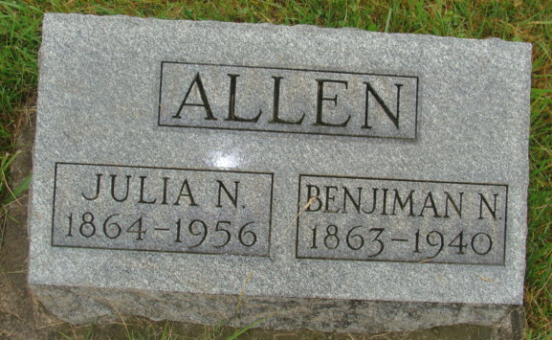
Photo by Alicia Kneuss
(Handwritten date: Monday, August 12, 1940)

BEN ALLEN, 77, EXPIRES SUNDAY
Funeral for Retired Broom Maker is Tuesday, P.M.

Benjamin Nathan Allen, 77, brother of Frank Allen here (cut in paper) ...of 20 weeks. He was a retired broom maker.
The decedent was born in Darke County, Ohio, March 1?, 1863, the son of Nathan and Margaret Knull Allen. He was a resident of this county during most of his life excepting the 25 years when he lived in Bluffton. He was married to Julia Ann Baker on February 1, 1883, the ceremony taking place in Wabash Township.
Surviving (crease in paper)...William of Chillicothe, Ohio, Mrs. Henry (Lulu) Yoder of Berne, and Voyle H. of LaPorte.
One daughter, Mrs. Mabel M?? Adams preceded. One brother, Frank, of E. Main Street, survives. Three brothers and one sister preceding were Sarah Ann, David, Daniel and John. Eleven grandchildren and seven (cut in paper)
...The body was removed to the Henry Yoder home from the Yager mortuary and the final rites will be held at 3:00 p.m. Tuesday (C.D.S.T.) with the Rev. Morris Coers, Bluffton, officiating.
He attended the Baptist church at Bluffton. Burial will be in the M.R.E. cemetery.

Adams Co. Historical Scrapbook 1939-1940
*****
Indiana, Death Certificates, 1899-2011
Name: Benjamin Nathen Allen
Gender: Male; Race: White; Age: 77 years, 6 months, 10 days; Marital Status: Married
Birth Date: 13 Mar 1857 (sic – should be 1863 per stone); Birth Place: Ohio Darke County
Death Date: 11 Aug 1940; Death Place: Berne, Adams, Indiana, USA
Father: Nathen Allenl Mother: Margaret Allen; Spouse: Julia Ann Baker Allen

