Lovina (Meyer) Allspaw
October 3, 1900 – November 30, 1980

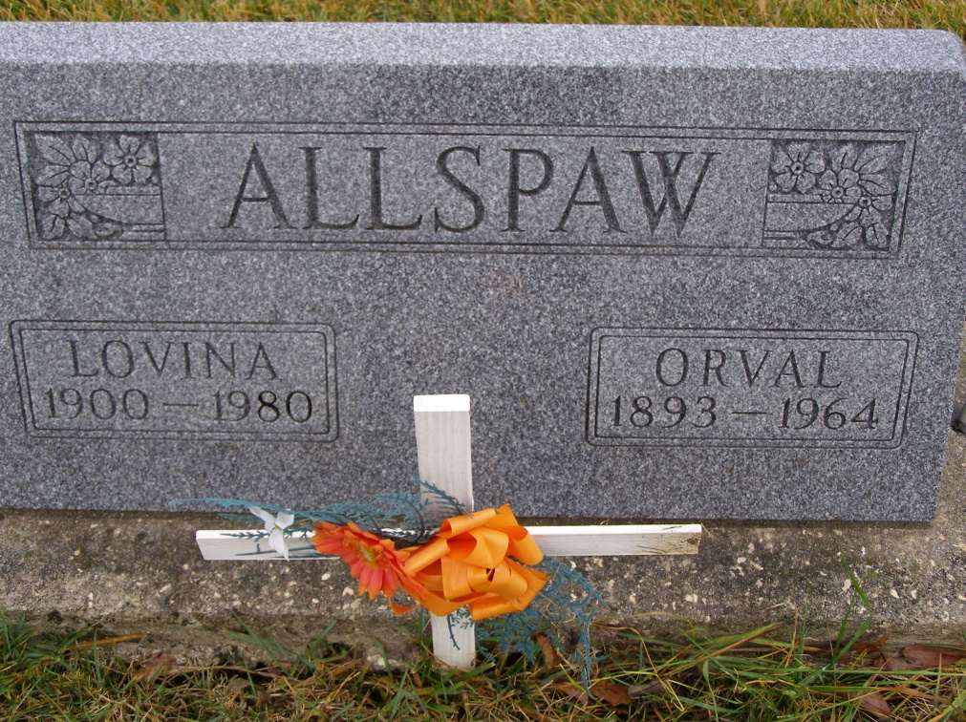
Photo by Shaunda Bedwell

Adams Public Library System (Decatur, IN) online obit abstracts
Publication: Decatur Daily Democrat; Date: December 1, 1980
Title: Allspaw, Lovina
Subject: Obituaries – A – 1980-1989
Abstract: Age: 80
Died: Sunday, November 30, 1980
Born: October 3, 1900
Daughter of Henry & Bertha Gehrig Meyer
Married: O. Allspaw – July 29, 1919
Notes: DPL Scrapbook 5-191-3

