Sharon E. Allspaw
March 4, 1931 – July 5, 1998

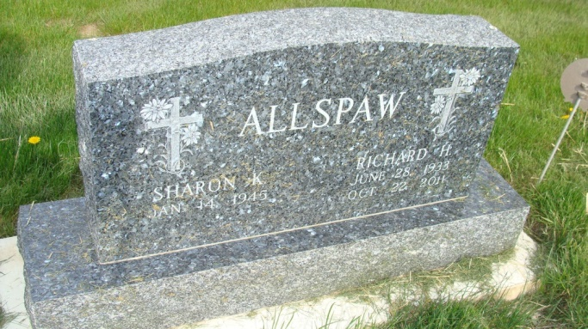
Photo by Alicia Kneuss

Sharon E. Allspaw, 67, of Berne, who owned and operated Sharon's Beauty Salon in Berne, died Sunday, July 5, at Swiss Village.
She also worked at Swiss Village Beauty Salon and CTS Corp. She belonged to Trinity United Methodist Church. In her leisure time, she enjoyed knitting afghans.
Surviving are an uncle, two aunts and several cousins.
Services are 10:30 a.m. Wednesday at the church, where calling begins an hour before services. Calling also is 3 to 8 p.m. today at Yager-Kirchhofer Funeral Home in Berne. Burial will be in M.R.E. Cemetery, Berne. Memorials are to Swiss Village Endowment Fund.

Fort Wayne News-Sentinel (IN); July 7, 1998

Contributed by Jane Edson

