Albert Amstutz
January 29, 1893 – November 21, 1947

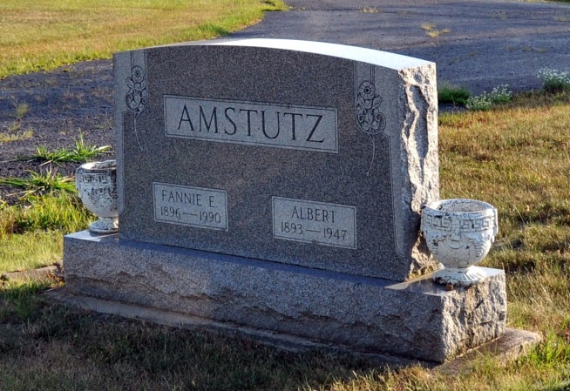
Photo by Deb Curry

ALBERT AMSTUTZ HANGS SELF AT LINN GROVE
FUNERAL MONDAY FOR FORMER BARBER; FOUND DEAD THIS FORENOON
Albert Amstutz, 54, widely known Linn Grove resident and a barber in that town for many years, died by hanging at about 9 or 9:30 a.m. today. Coroner Harmon Gillig intimated that he will return a verdict of suicide. Amstutz had not been well for some time and is said to have been despondent at times. The rash act was committed in a building owned by Amstutz and located just north of their residence in Linn Grove, a few feet west of the Wabash River in the center of the Linn Grove business district.
Mr. Amstutz's lifeless body was found by his wife about an hour after the act. He apparently died from strangulation. Amstutz had taken a small rope, thrown it over a board nailed across two joists and then stepped on a nail keg and jumped off. The building in which the incident occurred was formerly the Linn Grove Mill and is an old landmark. Amstutz used it as a tool and work shop and for storage space. The east door was open when his wife found him.
Amstutz suffered a breakdown in health more than a year ago and had spent some time in a hospital and rest home. He had not been well a few years ago but had apparently recovered.
The deceased was born in the community January 29, 1893, the son of John and Lydia Neuhauser Amstutz. He was married to Fanny Mertz January, 21, 1919. She survives, also the following children; Mrs. Leon (Elois) Meshberger, Linn Grove; Richard Amstutz, St. John's, Mich.; Earl Amstutz, Linn Grove; two grandchildren, Connie and Lynn Meshberger of Linn Grove; the following brothers and sisters; Henry and Reuben, Celina, Ohio; Ezra, Kidron, Ohio; Loren, Orrville, Ohio; Menno, Ashland, Ohio; John, Fort Wayne; Mrs. Truman Roth, Canton, Ohio; Mrs. Herbert Beltz, Fort Wayne; Mrs. Arthur Fox, Berne. The parents, a sister, Mrs. Aldine Schindler, and a brother, Herbert preceded in death.
Mr. Amstutz was a member of the Evangelical Mennonite Church. The body was brought to the Yager Mortuary and will be removed to the home in Linn Grove where it may be viewed after 6 p.m. Saturday.
The funeral will be held at 2 p.m. Monday at the Linn Grove Evangelical U. B. Church, Rev. N. J. Schmucker, pastor of the Evangelical Mennonite Church, officiating. The church funeral will follow a short service at the home. Burial will be in the M. R. E. Cemetery. The funeral will be held at the Linn Grove Church because the Evangelical Mennonite church of which he was a member is not available for the service because of a remodeling and building project now under way.

Berne Witness, Adams County, IN; November 21, 1947

Contributed by Karin King

