Bertha (Yoder) Amstutz
February 12, 1887 – April 3, 1940
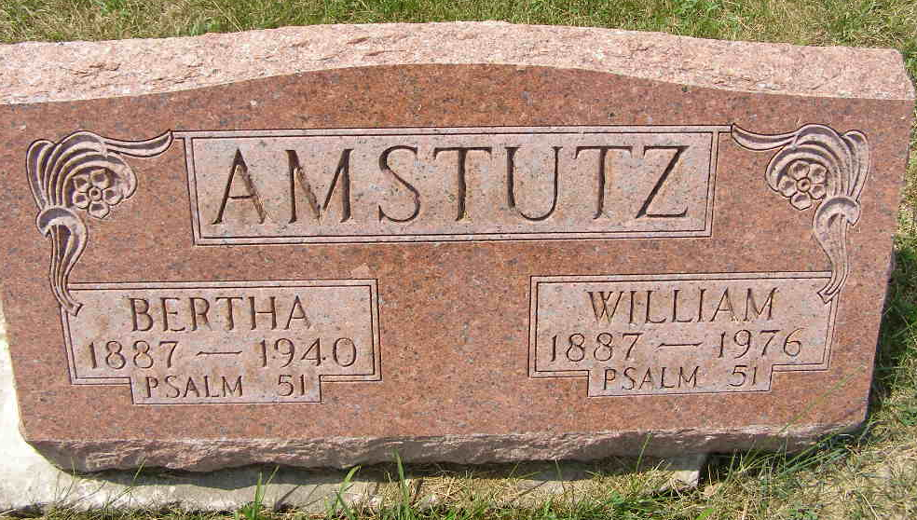
Photo by Shaunda Bedwell

(Handwritten date: Wednesday, April 3, 1940)

DEATH CLAIMS BERNE WOMAN
Mrs. William Amstutz Dies Early This Morning At Home In Berne

Mrs. Bertha Amstuz, 53, wife of William Amstutz, died at 6 o'clock this morning at her home in Berne. She had been in critical condition following a stroke of paralysis eight days ago.
She was born near Berne, February 12, 1887, the daughter of Peter and Fanny Moser-Yoder. She married William Amstutz, June 17, 1923. No children were born to their union.
Surviving besides the husband are three brothers, Henry and Elmer Yoder of Berne, and Levi Yoder of Linn Grove, and one sister, Mrs. Lydia Steiner of Geneva.
Mrs. Amstutz was a member of the Defenseless Mennonite church.
Funeral services will be held at the home at 1:30 p.m. Friday and at 2 o'clock at the church, Rev. N. J. Schmucker and Rev. C. J. Gerig officiating. Burial will be in the M.R.E. cemetery at Berne.

Adams County Historical Museum
1940 Feb-Dec Scrapbook – image 096
Transcribed by Karin King
*****
AMSTUTZ
Decatur, Apr. 3
Mrs. William Amstutz, 53, died at her home in Berne this morning after an eight-day illness of paralysis.
Surviving besides the husband are three brothers, Henry and Elmer Yoder of Berne and Levi Yoder of Linn Grove, and one sister, Mrs. Lydia Steiner of Geneva.
Funeral services will be held at the home at 1:30 PM Friday and at 2 o’clock at the Defenseless Mennonite Church. Burial will be in the M.R.E. Cemetery at Berne.
Journal-Gazette, Fort Wayne, IN; April 4, 1940
Contributed by Jim Cox

