Dwight Edward Amstutz
August 11, 1927 – August 19, 2007

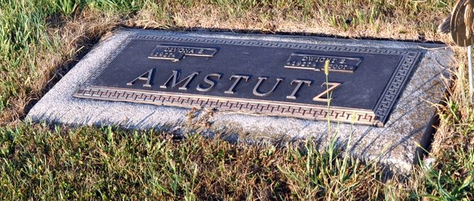
Photo by Deb Curry

Dwight Amstutz, 70 years old of Berne, Indiana, passed away at 5:05 p.m. on Sunday, August 19, 2007 at his residence.
He was born on August 11, 1927 in Adams County, Indiana, the son of the late Carl Amstutz and the late Elma (Roth) Amstutz. He married DeVona Habegger on July 27, 1948.
Dwight was a veteran of Merchant Marine from 1945 to 1947. He was a supervisor of the Mill Room at Dunbar Furniture with 30 years of service, worked for eleven years for the Pennsylvania Railroad as a clerk and for 16 years with Don Ray Drive-a-way in Decatur.
He was a member of the First Missionary Church, Berne, Indiana.
Surviving is his daughter, Laura (Ron) Simmons of Lake Wood, Colorado, daughter, Denise (Robert) Gregory of Kirkland, Washington, brother, Marvin Amstutz of Velencia, California, and two grandchildren, Nathan Simmons and Elliott Gregory. Preceding Dwight in death was one sister, Jeanette Sprunger; a grandson Jonathan M. Simmons.
Funeral service on Friday, 24th at 2 pm with calling 1 hour prior to the service; also at the funeral home on Thursday from 3 to 8 pm. Preferred memorials are to the First Missionary Church or Family Hospice of NE Indiana.

Yager-Kirchhofer Funeral Home online obit
(accessed August 20, 2007)

