Eldonna M (Habegger) Amstutz
October 15, 1934 – September 25, 1999

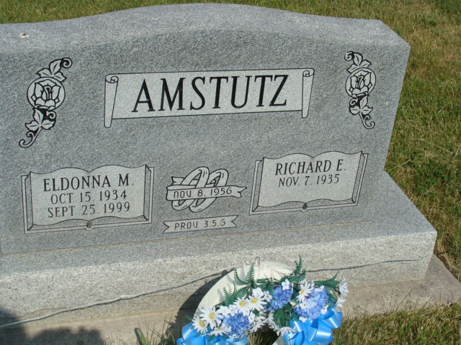
Photo by Alicia Kneuss

Eldonna M. Amstutz, 64, of Berne, died at 3:15 a.m. Saturday at Lutheran Hospital in Fort Wayne. She was a former employee of CTS Corp. of Berne, where she was employed for 20 years. She was born in Adams County Oct. 15, 1934 to Edgar and Savilla Roth Habegger. Her marriage on Nov. 8, 1956 at Berne was to Richard E. Amstutz, who survives.

Mrs. Amstutz attended the First Missionary Church at Berne. In addition to her husband, she is survived by two sons, Michael W. of Fort Wayne and Randall L. of Berne; a daughter, Mrs. Dale (Debra) Wilson of Fort Wayne; three brothers, Ben Habegger of Bluffton, Paul Habegger of Geneva and Alvin Habegger of Berne; three sisters, Hannah Schaadt of Berne, Mrs. William "Mac" (Katherine) Smith of Geneva and Mrs. Robert (Sarah) Amstutz of Granada Hills, Calif.; and six grandchildren. Two brothers are deceased.

Services at 10:30 a.m. Tuesday will be at the First Missionary Church in Berne with Rev. Harold Nussbaum and Rev. Gareth Wiederkehr officiating. Burial will be in the MRE Cemetery at Berne. Visitation hours at Yager-Kirchhofer Funeral Home in Berne are today from 2 to 9 p.m. and Tuesday from 8 to 9 a.m. and then at the church for one hour prior to services. Memorials to the First Missionary Church Missions.

Bluffton News Banner, Wells County, IN; Monday, September 27, 1999

Contributed by Karin King

