Homer Clinton Amstutz
October 13, 1904 – March 15, 2003

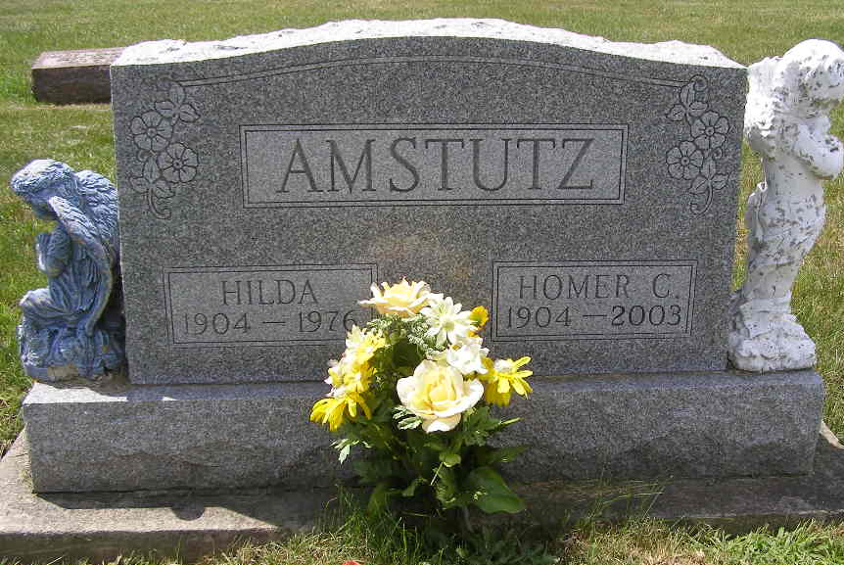
Photo by Deb Curry

Homer C. Amstutz, 98, of Berne, a member of First Missionary Church, died Saturday, March 15, 2003, at Adams County Memorial Hospital, Decatur.
The Adams County native had been a carpenter and cabinetmaker for more than 20 years. He worked at Dunbar Furniture and Berne Furniture, and had also been a Sunday school teacher.
Surviving are his sons, Gene D. of Berne and Larry N. of Fort Wayne; daughters, Bernadine Zuercher of Dover, Pa., and Carol Hill of Huntington; stepsons Warren Leonard of River Falls, Wis., Dr. Stanley Leonard of Prescott Valley, Ariz., and David Leonard of Alstead, N.H.; a stepdaughter, Joyce Sprunger of Huntington; sisters Leona Luginbill of Berne and Agnes Miller of Fort Wayne; 14 grandchildren; 18 step grandchildren; 41 great-grandchildren; 40 step greatgrandchildren; three great-great-grandchildren; and three step great-greatgrandchildren.
He was preceded in death by his first wife, Hilda; his second wife, Gladys; seven brothers; and a sister.
Services are 10 a.m. Tuesday at Swiss Village Chapel, Berne, with calling one hour before services and also from 5 to 8:30 p.m. today.
Burial will be at MRE Cemetery, Berne. Memorials are to the church missions.

News-Sentinel, Fort Wayne, IN; March 17, 2003

Contributed by Jane Edson

