Ida S. (Stauffer) Amstutz
October 23, 1898 – December 20, 1984

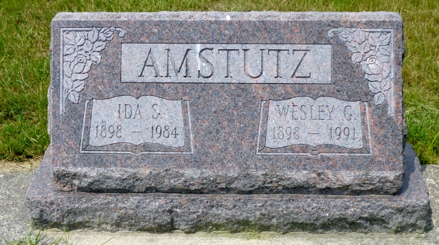
Photo by Rev. Max Haines

Adams Public Library System (Decatur, IN) online obit abstracts
Publication: Decatur Daily Democrat; Date: December 21, 1984
Title: Amstutz, Ida S.
Subject: Obituaries – A – 1980 – 1989
Abstract: Age: 86
Born: October 23, 1898
Died: December 20, 1984
Parents: Peter & Mary Sprunger-Stauffer
Spouse: Wesley Amstutz
Married: March 15, 1921
Notes: DPL Scrapbook 6-240-2

