Jacob U. Amstutz
November 20, 1862 – December 7, 1926

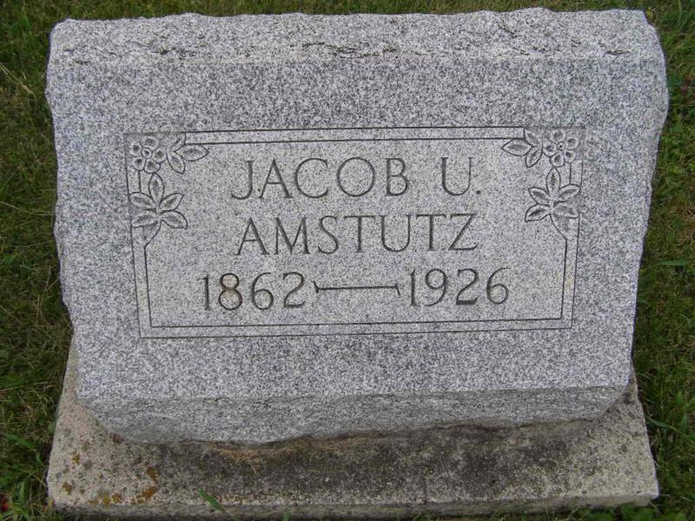
Photo by Deb Curry

Adams Public Library System (Decatur, IN) online obit abstracts
Publication: Decatur Daily Democrat; Date: December 9, 1926
Title: Amstutz, Jacob U.; Subject: Obituaries – A – 1920 - 1929
Abstract: Age: 64
Born: July 20, 1934
Died: Tuesday morning, December 7, 1926
*****

Indiana, Death Certificates, 1899-2011
Name: Jacob N Amstutz (looks like Jacob U)
Gender: Male; Race: White; Age: 64; Marital Status: Married
Birth Date: 20 Nov 1862; Birth Place: Indiana
Death Date: 7 Dec 1926; Death Place: Wabash, Adams, Indiana, USA
Father: Glerie Amstutz; Mother: Elizabeth Sprunger;
Spouse: Verena Amstutz, informant
Burial: 12/10/1926, MRE

