James Olen Amstutz
July 20, 1934 – November 23, 1984

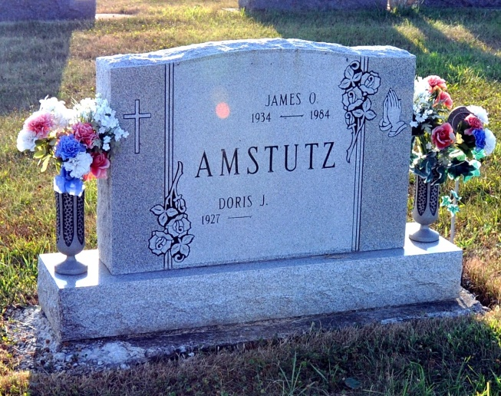
Photo Deb Curry
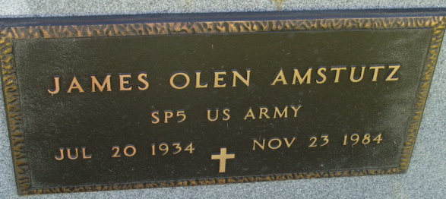
Photo by Alicia Kneuss

Adams Public Library System (Decatur, IN) online obit abstracts
Publication: Decatur Daily Democrat; Date: November 24, 1984
Title: Amstutz, James; Subject: Obituaries – A – 1980 – 1989
Abstract: AAge: 50
Born: July 20, 1934
Died: November 23, 1984
Notes: DPL Scrapbook 6-234-1

