John A. Amstutz
May 10, 1860 – July 26, 1934

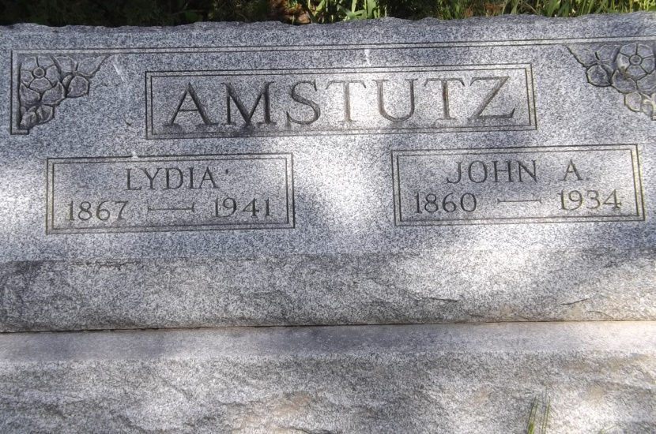
Photo by Jim Allen

(Handwritten: Thursday, July 26, 1934)
JOHN A. AMSTUTZ DIES TODAY AT HOME IN BERNE; Heat Hastens Death of Prominent Retired Farmer; FUNERAL ON SATURDAY A.M.
John A. Amstutz, age 74, prominent retired farmer, died at his home on North Jefferson Street this forenoon at 10:15 o'clock; Death came rather suddenly and unexpected, and was hastened by the extreme heat, according to the attending physician. The heat was indirectly responsible for his death, the doctor said.
Mr. Amstutz had been in poor health for ten years, but was up and around as usual until Wednesday when he became sick. His condition grew worse rapidly and became alarming last night. This morning it was apparent that he was failing fast.
John A. Amstutz was born near Pandora, Ohio, on May 10, 1860, bringing his age to 74 years, 2 months and 16 days. He was a son of Christian and Maria Nussbaum Amstutz, both natives of Switzerland.
Mr. Amstutz spent most of his life in this community. On July 28, 1899, he was united in marriage to Lydia Neuhauser. The marriage took place at the Defenseless Mennonite Church west of Berne. The couple moved on a farm in French Township and lived there for many years. The farm is located three miles north and about two and one-half miles west of Berne, where Edwin Beer, French Township Trustee now resides. The couple moved to Berne several years ago, when Mr. Amstutz retired from farming.
Surviving are the widow, and the following children: Mrs. Reuben Schindler, Henry Amstutz, both of Berne; Albert Amstutz of Linn Grove; John Amstutz of Fort Wayne; Mrs. Herbert A. Beltz of Fort Wayne; Mrs. Truman Roth of Celina, Ohio; Menno Amstutz, Monroe; Ezra, Ella and Loren Amstutz, all at home and Reuben Amstutz of Celina, Ohio. Two sons, Noah and Amos, died in infancy.
A large number of grandchildren and the following sisters and brothers survive: Mrs. Anna Diller, Pandora, Ohio; Mrs. Peter Fox, Linn Grove; Mrs. David Zimmerman, near Geneva; Mrs. Peter Klopfenstein of near Monroe; Mrs. Carey Templin, Berne; Daniel Amstutz, Fort Recovery, Ohio; Amos Amstutz, Grabill, Indiana and William Amstutz, near Decatur. Three brothers, Noah, David, Christian, and one sister, Mrs. Andrew Mertz preceded him.
Mr. Amstutz was a member of the West Missionary Church.
The funeral will be held Saturday forenoon at 9 o'clock at the home here, and at 9:30 o'clock at the Linn Grove Missionary Church, Rev. Alfred Clauser and Rev. H. E. Tropf officiating. Burial will be in M.R.E. cemetery.

Adams County (IN) Historical Museum
1934 Scrapbook, image 075
Transcribed by Karin King

