Katharine Janice (Lehman) Amstutz
August 6, 1920 – December 31, 1995

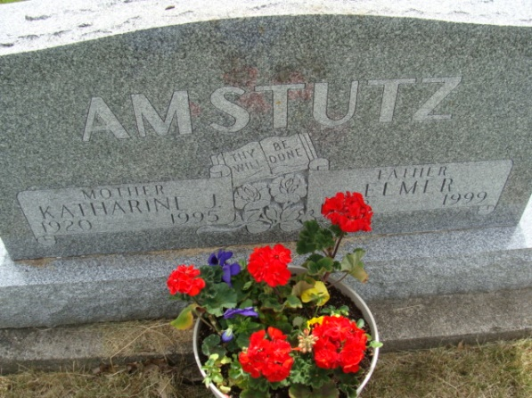
Photo by Alicia Kneuss
Katherine J. Amstutz, 75, Berne, died at home at 10:50 p.m. Sunday after having been ill with cancer since 1989.She was born on Aug. 6, 1920 in Adams County to Otto B. and Hulda Habegger Lehman and married Elmer Amstutz on June 1, 1941. He survives.
She was a homemaker, a retired employee of Berne Overall Co., and recently a representative selling Shaklee products. She was a member of First Missionary Church in Berne and a Sunday School teacher for more than 30 years.
Other survivors are three sons, David Amstutz, address unknown; John Amstutz, rural Geneva; and Dan Amstutz, Berne; four daughters, Mrs. James (Louise) Neuenschwander and Mrs. Wilkie "Bud" (Esther) Bush, both of Berne; Mrs. Jay (Gloria) Sprunger, Geneva; and Mrs. David (Sara) May, rural Berne; three brothers, Abraham, and Eldon Lehman, both of Berne and Thomas Lehman, Wolcottville, Indiana; a sister, Clorinda Yoder, Berne; two half-sisters, Bonnie Breauchy, Berne and Mrs. William (Betty) Von Gunten, Decatur; 13 grandchildren and one great-grandchild. Four sisters, Ernestine Bixler, Rhoda Gerber, Erna Lehman and Eve Lehman, and a half-brother, Dwight Lehman, are deceased.
There will be a graveside service at 9:30 a.m. Thursday in MRE Cemetery, Berne, followed by a memorial service at 10:30 a.m. in First Missionary Church. Visiting hours are 2-9 p.m. Wednesday and 8-9:15 a.m. Thursday in Yager-Kirchhofer Funeral Home, Berne. Preferred memorials are to the church.

Yager-Kirchhofer Funeral Home online obit (accessed January 1, 1996)

