Kathryn (Stauffer) Amstutz
April 19, 1902 – July 8, 1979

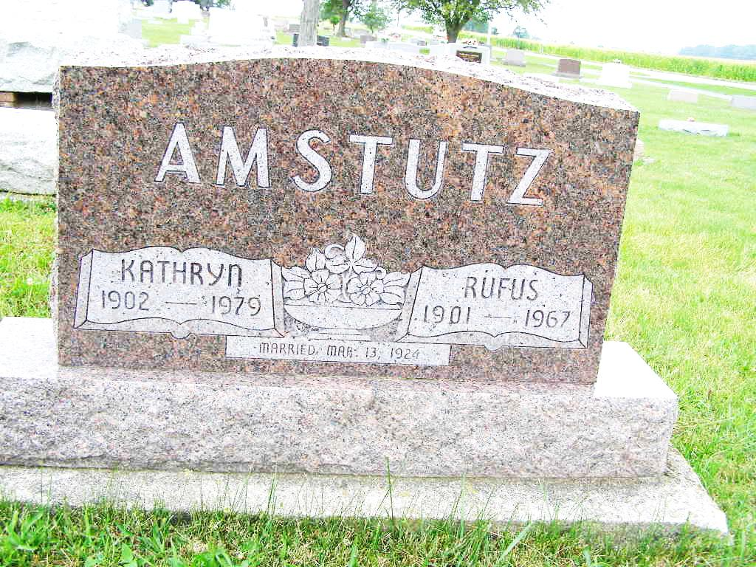
Photo by Shaunda Bedwell

Kathryn Amstutz, 77, formerly of Berne, and recently of Bonham, Texas, died Sunday in a Bonham hospital after a short illness. Born April 19, 1902 in Adams County to Peter and Mary Sprunger-Stauffer, Mrs. Amstutz worked for a time at the Economy Printing Concern in Berne. A member of First Missionary Church in Berne, she was preceded in death by her husband, Rufus Amstutz.
One son, Roger, of Bonham, Texas, survives. Also surviving are three sisters: Mrs. G. W. (Metta) Hamma of Indianapolis, Mrs. Wesley (Ida) Amstutz of Berne, and Mrs. Edmund (Deane) Bernett of Indianapolis; one brother, Palmer Stauffer, Glendale, California; six grandchildren and one great-grandchild.
Funeral services will be held at the First Missionary Church in Berne at 2 p.m. Thursday, the Rev. James Jackson in charge. Burial will be in the MRE Cemetery. Calling hours will be after 2 p.m. Wednesday at Yager Funeral Home in Berne.

Decatur Daily Democrat, Adams County, IN; Tuesday, July 10, 1979

