Majeska J. (Ineichen) Amstutz
March 2, 1919 – June 29, 2008

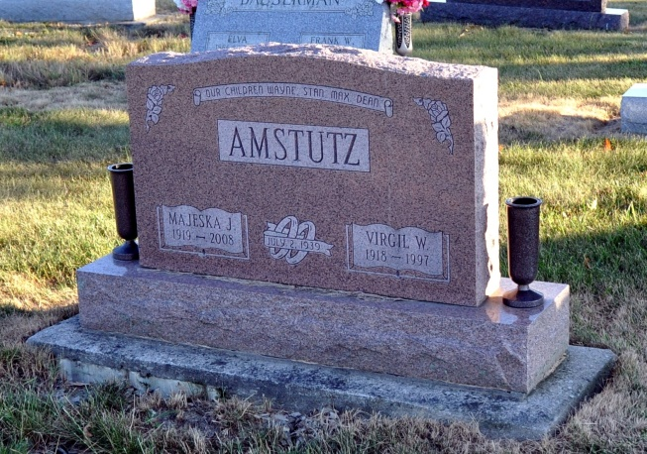
Photo by Deb Curry

Majeska Amstutz, 89, of Berne, died at 11:50 a.m., at Swiss Village. She was born to Harve and Nellie (Kerr) Ineichen. On July 2, 1939, she married Virgil Amstutz, who died in 1997.
Surviving are four sons, Wayne (Sheila), Berne, Stanley (Mary), Fort Wayne, Rev. Max (Lorraine), Port Huron, MI, and Dean (Linda), Fishers; a sister, Marjorie Shoemaker, Jonesboro; 12 grandchildren, 13 great-grandchildren and three great-great grandchildren.
She retired from Berne Economy, where she worked as a receptionist, and was associated with Amstutz Hatcheries, in Celina and New Bremen. She was a member of the First Missionary Church and its Women's Guild, Berne.
Services are at Swiss Village Chapel, the Revs. Max Amstutz, Anita Rediger and Gareth Wiederkehr officiating.

Yager-Kirchhofer Funeral Home online obit (accessed June 30, 2008)

