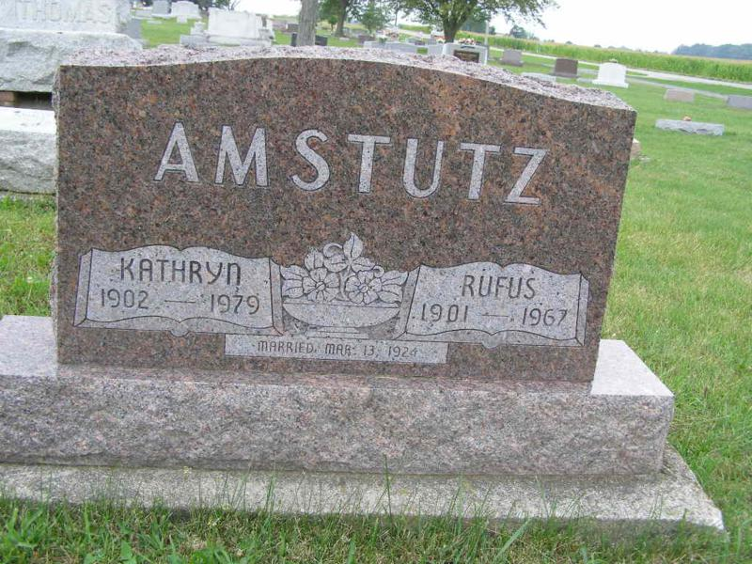
Rufus P. Amstutz

Photo by Shaunda Bedwell

Rufus P. Amstutz
Date of Death: June 25, 1967; Date of Burial: June 27, 1967; Burial: Lot 209, Orig. Platt

Rufus Amstutz Dies Sunday in County Hospital
Funeral Here Tuesday for Prominent Local Man, 65

Rufus P. Amstutz, 65, widely known local man, died at 2:15 am Sunday in the Adams County Memorial Hospital. Mr. Amstutz, who resided at 318 East Water Street, submitted to surgery Wednesday morning and had been seriously ill since. Death was attributed to a heart attack.
Mr. Amstutz had not been well since he was seriously injured in a traffic accident two years ago.
He was employed by Smith Brothers Furniture Company of this city.
A lifelong resident of this community, Mr. Amstutz was born in Wabash Township July 1, 1901, a son of Jacob and Verena Habegger Amstutz. He was married to Katherine Stauffer March 13, 1924 in Fort Wayne.
Surviving are the wife; a son, Roger L. Amstutz of Garland, Texas; six grandchildren; six brothers, Rev. Jesse M. Amstutz, Roseville, Michigan; Wesley G., Homer C., Oswin M. and Clifton H., all of Berne and community and Vilas A. Amstutz, Van Nuys, California; four sisters, Miss Sylvia N. Amstutz, Fort Wayne, Mrs. W. O. (Celina) Klopfenstein, Fort Wayne; Mrs. Irwin (Leona) Oyer, Grabill and Mrs. Frank (Agnes C.) Miller, Fort Wayne. A daughter, Alice, died at the age of seven and a son preceded in death in infancy. A brother, Elmer is deceased.
Mr. Amstutz was a member of the First Missionary Church here and services will be held at 2 pm Tuesday. Rev. Gerald Gerig (cut off)
Berne Library Heritage Room (IN) MRE Obit Book 1966-1972, image 84 Transcribed by Jim Cox

