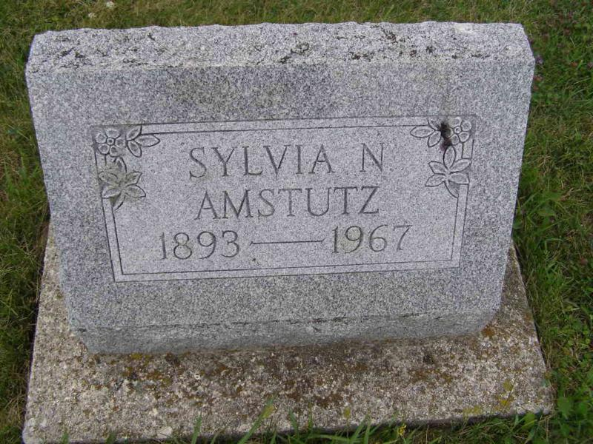
Sylvia N. Amstutz

Photo by Shaunda Bedwell
Sylvia N. Amstutz
Date of Death: September 16, 1967
Date of Burial: September 18, 1967
Burial: Lot 204, Orig. Platt

Miss Sylvia N. Amstutz
Services for Miss Sylvia N. Amstutz, 74, who died at 6 am yesterday in the Twin Maples Nursing Home, will be at 2 pm Monday at Chalfant-Perry-Klaehn Funeral Home, The Rev. C. Vlot officiating Burial will be at Berne.
Miss Amstutz was a patient at the nursing home for eight months. She was a native of Berne and was employed at the Lutheran Hospital here as a nurses aid for many years. She was a member of the First Missionary Church.
Surviving are three sisters and six brothers: Mrs. Celina Klopenstein and Mrs. Agnes Miller, both of Fort Wayne; Mrs. Leona Oyer, Grabill; Jesse Amstutz, Roseville, Mich.; Wesley, Homer, Oswin, and Clifton Amstutz, all of Berne; and Velas Amstutz of Van Nuys, Calif.
Friends may call at the funeral home after 3 pm today.
Berne Library Heritage Room (IN)
MRE Obit Book 1966-1972, image 90
Transcribed by Jim Cox

