Thomas S. Arnold
May 2, 1955 – January 3, 2018

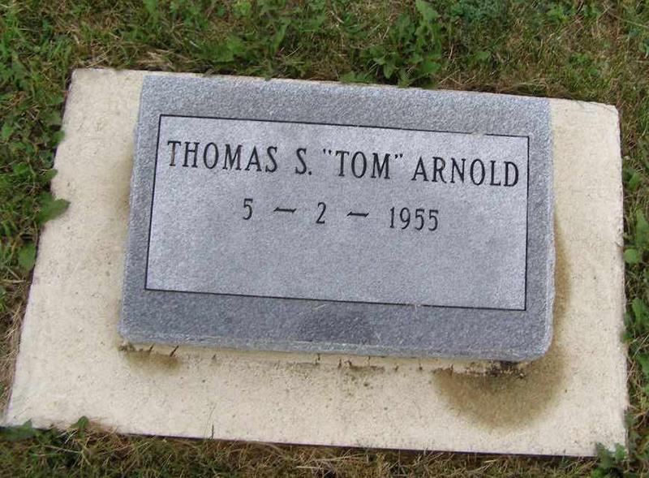
Photo by Shaunda Bedwell

Thomas S. "Tom" Arnold, 62, Sweetser, In., formerly of Berne passed away on January 3, 2018 at Visiting Nurse Hospice Home in Ft. Wayne.
He was born on May 2, 1955 in Adams County to Glenwood and Norma Cook Arnold. He married Jane Speidel on February 12, 2012.
Tom was a member of the Cornerstone Baptist Church in Portland. He was employed at the General Motors Plant in Marion, IN. His interests included kite flying, collecting coins and knives, yardwork, landscaping, and family gatherings.
Survivors include; his wife, Jane, sons; Chad Arnold of Muncie, Steven Caylor of Owings, MD., brother, Robert (Sarah) Arnold of Logansport, sister, Carolyn Sue Arnold of Ceylon, and 3 grandchildren, Marissa Arnold, Tyler and Peyton Caylor. Preceding in death are his parents.
Funeral services are Monday, January 8 at 1:00 pm at the Cornerstone Baptist Church, Portland with visitation from 10:00 am to time of services. Officiating is Pastor Wayne Ward with burial in the MRE Cemetery, Berne.
Preferred memorials to Cancer Services of N E Indiana, 6316 Mutual Dr., Ft. Wayne, IN 46825.
Yager-Kirchhofer Funeral Home online obit (accessed 1/4/2018)

