Shirley J. (Smith) Ashbrook
August 10, 1941 – March 26, 1974

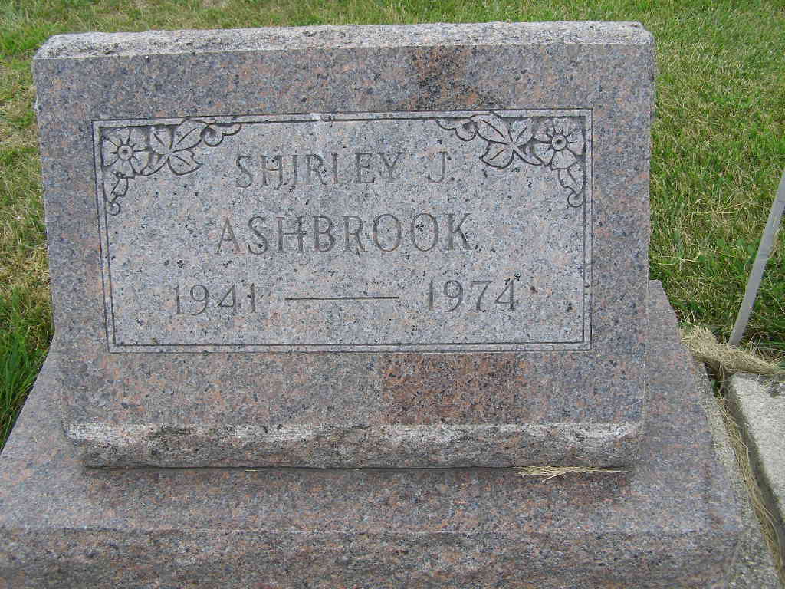
Photo by Shaunda Bedwell

Adams Public Library System (Decatur, IN) online obit abstracts
Publication: Decatur Daily Democrat; Date: March 27, 1974
Title: Ashbrook, Mrs. Shirley J.; Subject: Obituaries – A – 1970 – 1979
Abstract: Age: 32
Died: Tuesday, March 26, 1974
Born: August 10, 1941
Daughter of: Charles & Naomi Miller Smith
Notes: DPL Scrapbook 3-52-8

