Chester E. Augsburger
January 5, 1919 – December 22, 1977

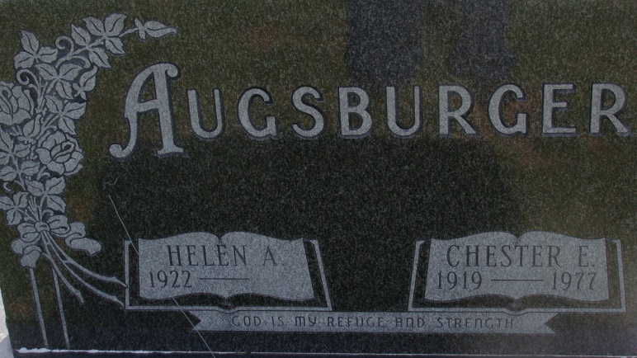
Photo by Alicia Kneuss

Adams Public Library System (Decatur, IN) online obit abstracts
Publication: Decatur Daily Democrat; Date: December 23, 1977
Title: Augsburger, Chester E
Subject: Obituaries – A – 1970 – 1979
Abstract: Age: 58
Born: January 5, 1919 – Hartford Township Adams County
Died: December 22, 1977
Married: Helen Butcher
Notes: DPL Scrapbook 4-219-5

