Lillie Marie (Kneuss) Augsburger
November 21, 1913 – August 19, 2000
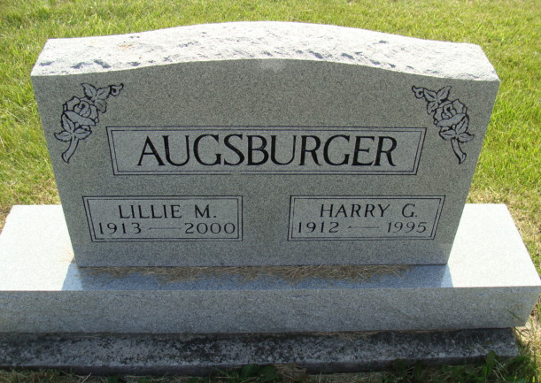
Photo by Alicia Kneuss

Lillie M. Augsburger, 86, died Saturday at Swiss Village, Berne. Born in Missouri, she was self-employed in the drapery business. Her husband, Harry G., died in 1995.
Surviving are two sons, David Augsburger of Berne and Lyle Augsburger of Fort Wayne; a daughter, Kathleen Kohl of Elkhart; six grandchildren; and six greatgrandchildren.
Services at 10 a.m. Tuesday at First Missionary Church, Berne, with calling one hour before services. Calling also from 2 to 8 p.m. Monday at Yager-Kirchhofer Funeral Home, Berne. Burial in M.R.E. Cemetery, Berne. Memorials to the church or Swiss Village.
Journal Gazette, Fort Wayne, IN; August 20, 2000
Contributed by Jane Edson

