Mary Ann (Neuenschwander) Augsburger
September 27, 1910 – October 31, 1947

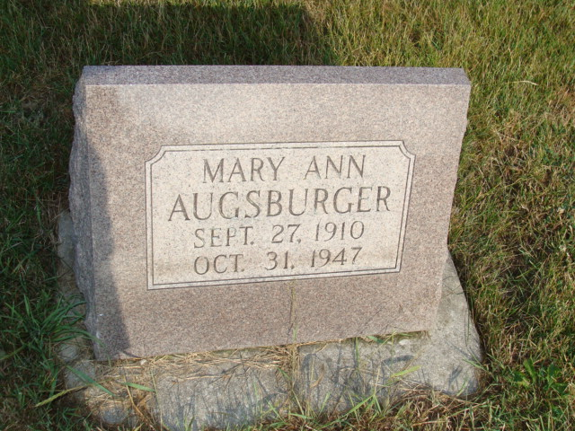
Photo by Alicia Kneuss

Adams Public Library System (Decatur, IN) online obit abstracts
Publication: Decatur Daily Democrat; Date: October 31, 1947
Title: Augsburger, Maryann Neuenschwander
Subject: Obituaries – A – 1940 – 1949
Abstract: Age: 37
Parents: Mr. and Mrs. Edwin (Mary Moser) Neuenschwander
Born: September 27, 1910
Spouse: Sylvanus Augsburger

