Harmon N. Bagley
June 30, 1907 – November 26, 1969
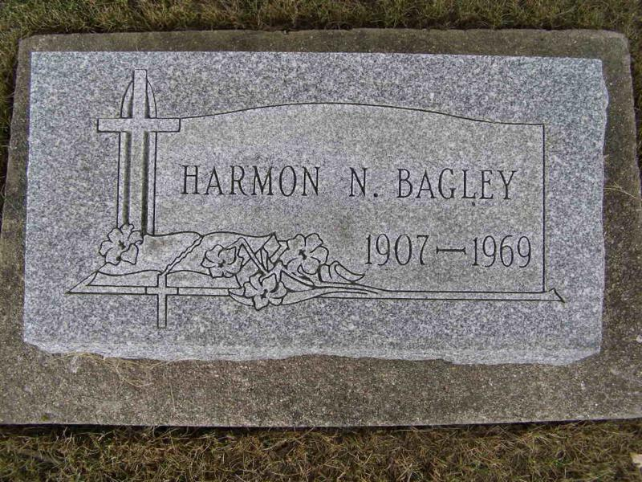
Photo by Shaunda Bedwell
Harmon Bagley
Date of Death: November 26, 1969
Date of Burial: November 30, 1969
Burial: Lot 297, Original Platt

Harmon Bagley Dies Suddenly Late Wednesday
Body Being Returned Here from Florida; Rites Sunday

Harmon Bagley, 62, Ft. Lauderdale, Florida, a native of Berne, died unexpectedly at his home at 9 pm Wednesday. For many years he spent the winters at Ft. Lauderdale and the summers here.
Death is believed to have been caused by a heart attack, probably, according to relatives, brought on by a blood clot. He had a heart ailment for some time, but was able to keep working. He had complained much of the summer of severe pain in a leg and hip and the leg often swelled up quite badly. Wednesday shortly before he died he told his wife he had an intense pain in his hip and leg. He had been in his Florida home since August after spending the early part of the summer here. While here during the summers, he lived in a mobile home at Trees south of Berne.
Bagley will be remembered by many as one of the top all time high school athletes in Berne High School. He played center on the Berne High School basketball team known as the Fighting Five and coached by the late Jerome Diltz. One year they completed the schedule undefeated, and then won the sectional before losing in the regional. Later he played independent ball.
He was engaged in construction work for many years, sometimes on his own, also with his brother, Victor Bagley of Fort Wayne, and in recent years with Wayne Reusser. He was also a bricklayer, built the Parkway Restaurant which he operated for some time. He also built several homes in Berne, Decatur and other places. For many years, he was associated with the Burroughs Adding Machine Company.
He graduated from Berne High School in 1928 and later from an air conditioning school in Chicago.
Bagley was born in Berne June 30, 1907, a son of Abraham and Bertha Gilliom Bagley. He was married to Josephine Reusser, a daughter of the late Dr. and Mrs. Amos Reusser, September 1, 1929.
Surviving are the wife; three daughters, Mrs. Sally B. Trinidad, Hawaii; Mrs. David (Gretchen) Shepherd, Light House Point, Florida and Mrs. Cal (Jennifer) Jones, Fort Lauderdale, Florida; six grandsons; a brother, Victor Bagley, Fort Wayne and four sisters, Mrs. Martha Beavers, Geneva; Mrs. Lila Wagoner, Springfield, Ohio; Mrs. Charles (Nora) Sims, Riverbank , California and Mrs. Glennys Williams, Los Angeles, Calif.
The body is being returned to Berne for funeral. It is due in Fort Wayne late tonight and friends may call at the Yager Funeral Home after 10 am Saturday.
Services will be held at the funeral home at 2 pm Sunday. Rev. Gordon Neuenschwander, pastor of the First Mennonite Church of which he was a member, officiating. Burial will be in the MRE Cemetery.

Berne (IN) Library Heritage Room
MRE Obits 1969 – 1972
Transcribed by Jim Cox

