Emma F. Baumgartner
October 18, 1876 – December 19, 1970

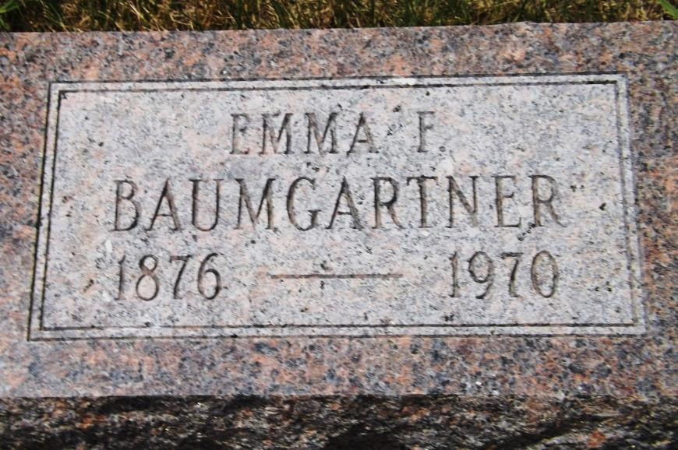
Photo by Jim Allen

Date of Death: December 19, 1970; Date of Burial: December 22, 1970
Burial: Lot 41, Original Platt

Miss Emma F. Baumgartner Dies Saturday
French Twp. Native to be Buried Here Tuesday

Miss Emma F. Baumgartner, 94, the daughter of Abraham and Caroline Ellenberger Baumgartner, died Saturday afternoon at 4:30 at the Mennonite Memorial Home at Bluffton, Ohio, where she was a resident for the past thirteen years. She had been ill only a day and death was caused by complications.
She was born on October 18, 1876, in French Township, and later moved with her parents to Monroe Township. However, she spent the greatest part of her life in Berne and was well-known in the community.
She was a member of the First Mennonite Church.
She is survived by one brother, Samuel L. Baumgartner of Monroe and forty nieces and nephews. In addition to the parents, she was preceded in death by three brothers: Albert, Edward and Noah Baumgartner and six sisters: Josephine (Mrs. Christian Wittwer), Mathilda (Mrs. Levi Sprunger), Louise (Mrs. David Winteregg), Ellen (Mrs. John Nussbaum), Ida (Mrs. Peter Nussbaum), and Caroline (Mrs. Noah Augsburger).
The body will be brought to the Chapel at the First Mennonite Church here at 11:00 am Tuesday where friends may call until the time of the funeral service at 2:00 o’clock. Rev. Gordon Neuenschwander, pastor, will officiate and burial will be in the MRE Cemetery.

Berne (IN) Library Heritage Room
MRE Obits 1962-1969
Transcribed by Jim Cox

