Gresham A “Bud” Bearss
August 16, 1937 – August 5, 2017

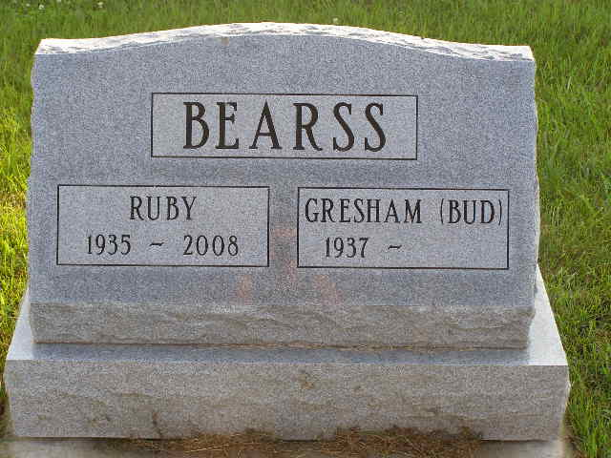
Photo by Shaunda Bedwell

Gresham A. "Bud" Bearss, 79, of Berne unexpectedly went home to be with his Lord and Savior Jesus Christ on August 5, 2017. He married Ruby Rhodes on August 17, 1958.
Bud was born on August 16, 1937 to George and Merceda Boyd Bearss in Mexico, IN. A graduate of Rochester High School, he earned his bachelor's degree in education from Manchester College and his master's in education from Purdue University. His 40-year career included classroom teaching in Caston, Mentone, Southmont, and South Adams school systems and retired as assistant superintendent of South Adams Schools.
A member of the First Missionary Church, Bud taught the Crusaders Sunday School class for many years and mentored several generations of students and younger adults. He was well known as a diehard sports fan-rooting unfailingly for the Chicago Cubs and Bears, the Purdue Boilermakers, and the South Adams Starfires. He also coached basketball and track early on in his teaching career. Bud enjoyed studying and teaching the Bible, listening to on-line sermons, traveling, fishing, playing card games, reading, eating out with friends and family, and keeping in touch with all the people he cared about via social media.
Survivors include daughters, Laura (Jim) Umpleby of Elkhart, IN, Kris Bearss and Barbara Bearss both of Nashville, TN; sister, Janis (Juan) Garcia of Pueblo, Mexico; brother, Wendell Bearss of Rochester, IN; and five grandchildren: Tim, Tyler, Kyrsten, and Karis Umpleby and Malachi Reid.
Preceding in death are his parents, wife, and sister Frances (Donald) Smith.
Funeral services are Wednesday, August 9, 2017 at 10:30 am at the First Missionary Church with visitation 1 hour prior to services. Visitation also Tuesday, August 8 from 2 to 8 pm at the First Missionary Church. Officiating is Pastor Kris McPherson, Burial is in the MRE Cemetery, Berne.
Preferred memorials to Big JAWS Youth for Christ &/or Hope Center, Fort Wayne or Berne Hope Clinic.

Yager-Kirchhofer Funeral Home online obit (accessed 08/07/2017)

