Garry L. Bluhm
February 19, 1942 – February 23, 1974
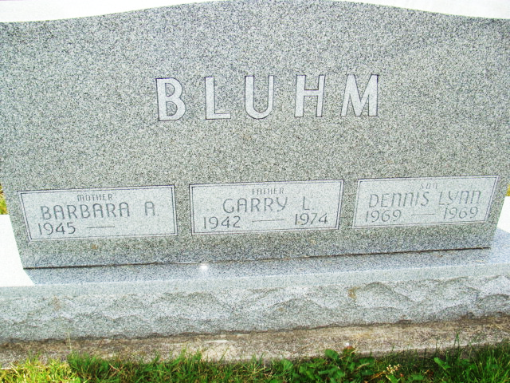
Photo by Alicia Kneuss

GARRY L. BLUHM, BERNE FURNITURE EMPLOYEE, 32, DIES
Services will be held at 2 p.m. Tuesday at the United Methodist church in Monroe, Rev. Donald Wilks officiating. Burial will be in the M.R.E. cemetery.
The body is at the Winteregg-Linn and Haggard Funeral Home in Decatur where friends may call until 11:30 a.m. Tuesday when the body will be taken to the church to lie in state until the time of the service.
Preferred memorials are to Jeanine Sprat surgical nurse to Dr. Ernest Steury at the Ten-Wek hospital in Kenya, East Africa or to your favorite charity.
*****
Garry L. Bluhm, 32, R.R. 1, Monroe died at 12:45 p.m. at Parkview Memorial hospital following an illness of two days. Death is attributed to a ruptured blood vessel in his brain. [Photo]
Mr. Bluhm was employed by the Berne Furniture Company for the past few years and also did some farming. He became ill Thursday evening while doing chores. All efforts by specialists and doctors to save his life were futile, including surgery performed Friday night. The ailment which took his life is to have existed since birth.
The Bluhm family resides on the former Rufus Nussbaum farm northeast of Berne.
He was born in this community February 19, 1942, a son of Roger and Earlene Stucky Bluhm. He was married to Barbara Wolff, Sept. 7, 1963.
Bluhm was a member of the Monroe United Methodist church and was active in church work, being chairman of the current expenses committee, a member of the administrative board and the pastor-parsonage committee.
The wife survives, also two sons, Paul Roger and James Daniel, both at home; the parents of R.R. 1, Monroe, the grandfather, Raymond Bluhm of Swiss Village and three brothers, Gene and John Bluhm of R.R. 1, Monroe and Ben Bluhm, R.R. 1, Berne. A son, Dennis Lynn is deceased.

Garry Bluhm Burial on S1/2 Lot 58 Sec 1 4th Add.
Death Date: 23 Feb 74 Burial Date: 26 Feb 1974

Berne (IN) Library Heritage Room MRE Obits 1973-1984, image 049
Transcribed by Joey Pedigo

