Lura M. (Fields) Brooks
1886 – April 5, 1969
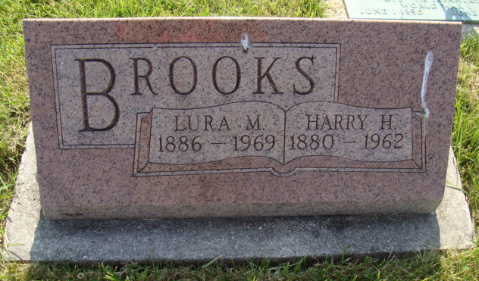
Photo by Alicia Kneuss

Lura M. Brooks
Date of Death: April 5, 1969
Date of Burial: April 7, 1969
Burial: MRE – S ½ 43, Sect. 1, 5th Addition

Mother of Mrs. Iris Lehman Dies Here Saturday PM
Mrs. Lura Brooks, 83, mother of Mrs. Iris (Mildred) Lehman, 169 West Franklin St., died at the home of her daughter Saturday afternoon at 1:15. She was a retired practical nurse and had been in failing health during the past year.
The deceased was a member of the Simpson Methodist Church in Fort Wayne.
Surviving besides her daughter is a brother, Milo Fields, Waco, Texas.
The funeral was held at 2 PM today in the Chalfant-Perry-Klaehn Funeral Home in Fort Wayne. Burial was in the MRE Cemetery here.
Berne (IN) Public Library Heritage Room
1968-1971 MRE Obit Scrapbook
Transcribed by Jim Cox

