John Christener, Jr.
October 3, 1918 – November 19, 1974

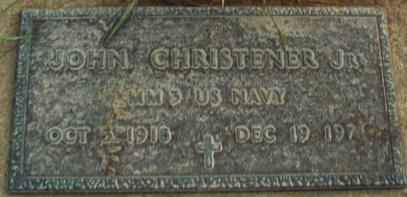
Photo by Alicia Kneuss
John Christener Jr., of Route 1 Monroe, a maintenance foreman at CTS of Berne, died at 2:30 p.m. Thursday at Caylor-Nickel Clinic, Bluffton, after being stricken with a heart attack earlier in the afternoon. He was 56. Mr. Christener was directing a truck through gates at the plant to the loading dock when stricken. He was rushed to Adams County Memorial Hospital and then transferred to Caylor-Nickel Clinic. He had been employed at CTS of Berne since 1960, and previously had operated Christener Plumbing and Heating in Monroe. A veteran of World War II, Mr. Christener served in the U.S. Navy in the Pacific Theater of Operations. He was a member of the Veterans of Foreign Wars. He was a lifelong resident of Adams County and a member of Monroe United Methodist. He was born in Washington Township Oct. 3, 1918, the son of John Sr. and Della (James) Christener, who are deceased, and was married Oct. 13, 1936 to the former Evelyn Bovine, who survives.
Also surviving are two daughters, Mrs. Marvin (Carolyn Kae) Taylor and Mrs. Marvin (Marilyn Mae) Schaadt, both of Monroe; a son, Robert G. of Monroe; two sisters, Miss Marie Christener of Route 1, Monroe, and Mrs. John (Bonnie) Burger of Rural Route, Convoy, O.; a brother Roger of Decatur; and 10 grandchildren.
Funeral services will be held at 2 p.m. Saturday at Zwick Funeral Home, Decatur, with the Rev. Donald E. Wilks officiating. Burial will be in MRE Cemetery. Friends may call at the funeral home after 2 p.m. today. Military services will be conducted by the VFW. Preferred memorials are to the Adams-Wells Training Center, Route 4, Bluffton.

John Christener; Burial Plot: 51-sec.3-4th ADD
Date of Death: Dec. 19, 1974; Date of Burial: Dec. 21, 1974

Berne Library Heritage Room
1973-1984 MRE Obit Book
*****
John Christener, Jr., 56, of route 1, Monroe, a maintenance foreman at CTS of Berne, died at 2:15 p.m. Thursday at the Caylor-Nickel Clinic, Bluffton, after being stricken with a heart attack two hours earlier near the plant.
The veteran CTS employee was directing a truck into the plant when he was stricken. He was rushed to Adams county memorial hospital and then taken to Caylor-Nickel.
He started his career at CTS on May 9, 1960, and had 14 years of service. He formerly operated Christener Plumbing & Heating in Monroe. Mr. Christener, a lifelong resident of Adams county, was a member of the Monroe United Methodist Church.
Veteran of World War II
He was a veteran of World War II, and served in the U.S. Navy in the Pacific Theater as fireman First Class. He was a charter member of the Veterans of Foreign Wars.
Born in Washington township on Oct. 3, 1918, he was a son of John and Della James-Christener, and was married on Oct. 13, 1936, to the former Evelyn Bovine who survives.
Also surviving are two daughters, Mrs. Marvin (Carolyn Kae) Taylor and Mrs. Marvin (Marilyn Mae) Schaadt, both of route 1, Monroe; a son, Robert G. of route 1, Monroe; two sisters, Miss Marie Christener of route 1, Monroe, and Mrs. John (Bonnie) Burger of rural route, Convoy, O; one brother, Roger of Decatur, and 10 grandchildren.
Funeral services will be conducted at 2 p.m. Saturday at the Zwick funeral home, with Rev. Donald E. Wilks officiating. Burial will be in the M.R.E. cemetery. Friends may call at the funeral home after 2 p.m. today. Military services will be conducted by the VFW. Preferred memorials are to the Adams-Wells Training Center, route 4, Bluffton.

Decatur Daily Democrat, Adams County, Indiana
Friday Dec. 20, 1974

