Rosa K. Christener
May 30, 1883 – March 1, 1975

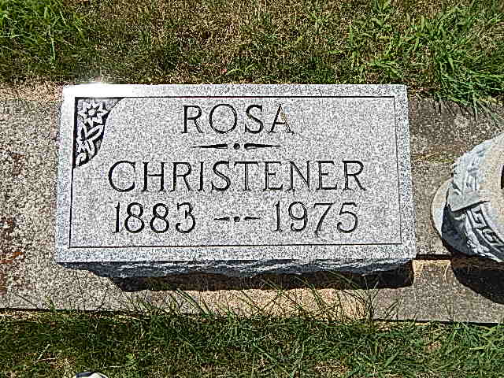
Photo by Alicia Kneuss

Miss Rosa Christener, 91, of route 1, Monroe, died at 1:15 a.m. this morning at the Decatur Community Care Center.
She was a member of the Tacoma Park Seventh Day Adventist Church, Washington, D.C.
Born in Monroe township on May 30, 1883, she was a daughter of Gottlieb and Magdelena Stauffer-Christener.
Survivors include four sisters, Mrs. Dwight L. (LaVon) Purdy of route 4; Mrs. Caroline Purvis of route 4; Miss Ida Christener of Berne; Miss Mary Christener, of Fort Wayne; three brothers, William Christener of route 1, Monroe, Fred Christener of route 1, Monroe, and Albert of Omer, Michigan.
Funeral services will be held at 10:30 a.m. Tuesday at the Yager funeral home, with Rev. Wilson Bixler and elder Dan Neegaard officiating. Burial will be in the M.R.E. cemetery. Friends may call at the funeral home from 2 p.m. to 5 p.m. Sunday, and after 2 p.m. on Monday.

Decatur Daily Democrat, Adams County, IN Saturday, March 1, 1975

*****
Rosa Christner (sic); Burial Plot: Lot 546-ORIG PLATT
Date of Death: March ??, 1975; Date of Burial: March 4, 1975

Services will be held at 10:30 a.m. Tuesday for Miss Rosa Christner, 91, a resident of the Decatur Community Care Center, who died at 1:15 a.m. Saturday, March 1, at the Decatur Community Care Center where she resided.
Rites will be at the Yager Funeral Home in Berne with Elder Dan Neergeard and Rev. Wilson Bixler officiating. Burial will be in the M.R.E. Cemetery. Friends can call at the funeral home after 2 p.m. today.
Miss Christner was born in Monroe Township May 30, 1883, a daughter of Gottlieb and Magdalena Stauffer Christner. She spent most of her life in the Monroe community. She was a member of the Tacoma Park Seventh (rest is cut off)

Berne (IN) Library Heritage Room
1973-1984 MRE Obit Book, image #83
Both contributed by Janice Vasilovski

